**VISVESVARAYA TECHNOLOGICAL UNIVERSITY**

**“JnanaSangama”, Belgaum -590014, Karnataka.**



**LAB RECORD**

**Computer Network Lab (23CS5PCCON)**

***Submitted by***

**Sidhvin Vidyadhar Burli(1BM21CS211)**

***in partial fulfillment for the award of the degree of***

**BACHELOR OF ENGINEERING**

***in***

**COMPUTER SCIENCE AND ENGINEERING**



**B.M.S. COLLEGE OF ENGINEERING**

**(Autonomous Institution under VTU)**

**BENGALURU-560019**

**Academic Year 2024-25 (odd)**

**B.M.S. College of Engineering**

**Bull Temple Road, Bangalore 560019**

(Affiliated To Visvesvaraya Technological University, Belgaum)

**Department of Computer Science and Engineering**



**CERTIFICATE**

This is to certify that the Lab work entitled “ Computer Network (23CS5PCCON)” carried out by **Sidhvin Vidyadhar Burli(1BM21CS211)** who is a bonafide student of **B.M.S. College of Engineering.** It is in partial fulfilment for the award of **Bachelor of Engineering in Computer Science and Engineering** of the Visvesvaraya Technological University, Belgaum. The Lab report has been approved as it satisfies the academic requirements of the above-mentioned subject and the work prescribed for the said degree.

|  |  |
| --- | --- |
| Srushti C S  Assistant Professor  Department of CSE, BMSCE | Dr. Kavitha Sooda  Professor & HOD  Department of CSE, BMSCE |

**Index**

|  |  |  |  |
| --- | --- | --- | --- |
| **Sl.**  **No.** | **Date** | **Experiment Title** | **Page No.** |
| 1 | 09-10-24 | Create a topology and simulate sending a simple PDU from source to destination using hub and switch as connecting devices and demonstrate ping messages. | 4-8 |
| 2 | 09-10-24 | Configure IP address to routers in packet tracer. Explore the following messages: ping responses, destination unreachable, request timed out, reply. | 9-11 |
| 3 | 16-10-24 | Configure default route, static route to the Router (Part 1). | 12-15 |
| 4 | 23-10-24 | Configure default route, static route to the Router (Part 2). | 16-20 |
| 5 | 13-11-24 | Configure DHCP within a LAN and outside LAN. | 21-26 |
| 6 | 20-11-24 | Configure RIP routing Protocol in Routers . | 27-30 |
| 7 | 20-11-24 | Demonstrate the TTL/ Life of a Packet. | 31-33 |
| 8 | 27-11-24 | Configure OSPF routing protocol. | 34-37 |
| 9 | 18-12-24 | Configure Web Server, DNS within a LAN. | 38-39 |
| 10 | 18-12-24 | To construct a simple LAN and understand the concept and operation of Address Resolution Protocol (ARP). | 40-42 |
| 11 | 18-12-24 | To understand the operation of TELNET by accessing the router in the server room from a PC in the IT office. | 43-45 |
| 12 | 18-12-24 | To construct a VLAN and make the PC’s communicate among a VLAN. | 46-49 |
| 13 | 18-12-24 | To construct a WLAN and make the nodes communicate wirelessly. | 50-52 |
| 14 | 18-12-24 | Write a program for error detecting code using CRC-CCITT (16-bits). | 53-54 |
| 15 | 18-12-24 | Write a program for congestion control using Leaky bucket algorithm. | 55-58 |
| 16 | 18-12-24 | Using TCP/IP sockets, write a client-server program to make the client send the file name and the server to send back the contents of the requested file if present. | 59-61 |
| 17 | 18-12-24 | Using UDP sockets, write a client-server program to make the client send the file name and the server to send back the contents of the requested file if present. | 62-64 |

Github Link: https://github.com/SidhvinBurli/CNLAB5TH

**Program 1**

**Aim:** Create a topology and simulate sending a simple PDU from source to destination using hub and switch as connecting devices and demonstrate ping messages.

**Topology , Procedure and Observation:** 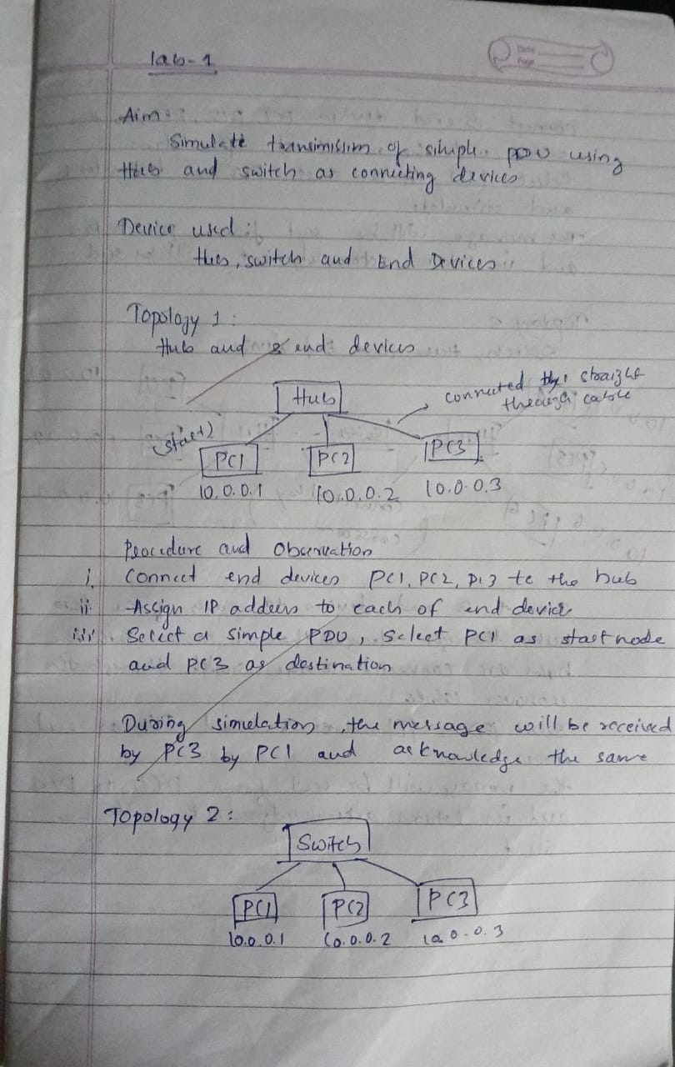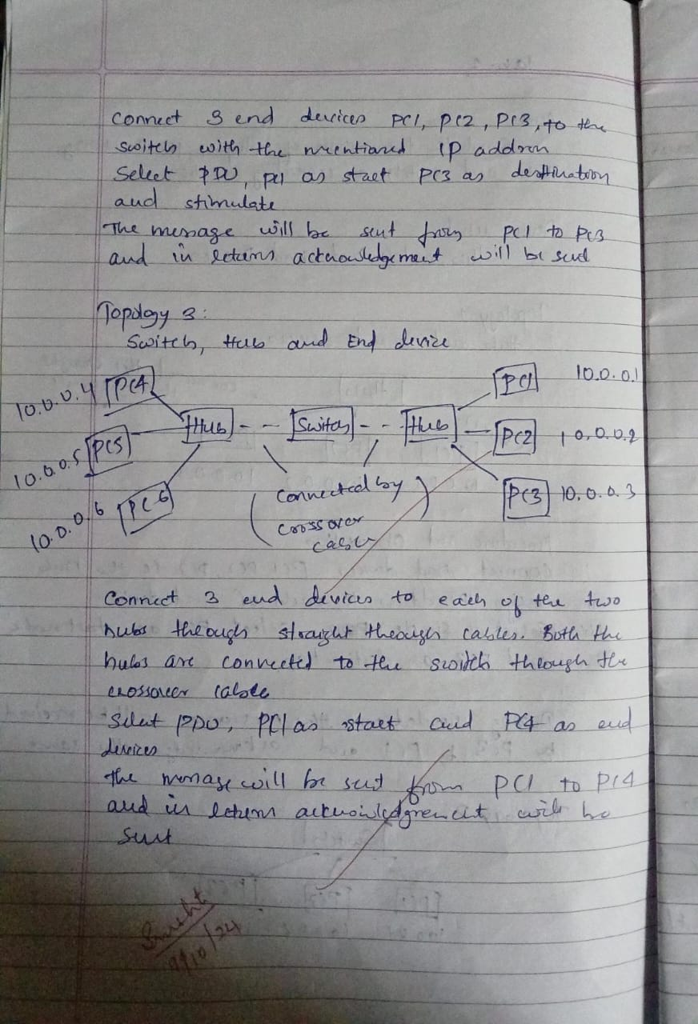

**Screen Shots:**

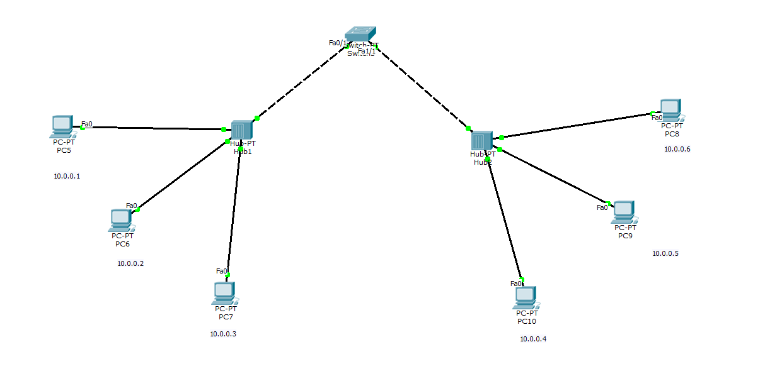

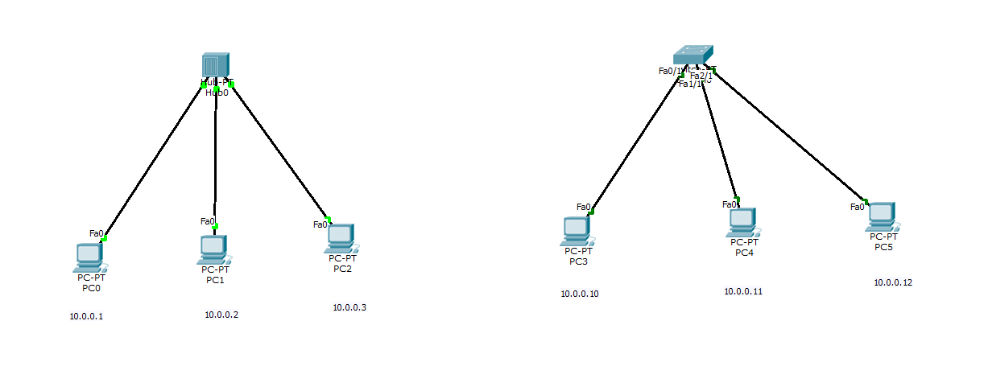

**Program 2**

**Aim:**Configure IP address to routers in packet tracer. Explore the following messages: ping responses, destination unreachable, request timed out, reply.

**Topology , Procedure and Observation:**

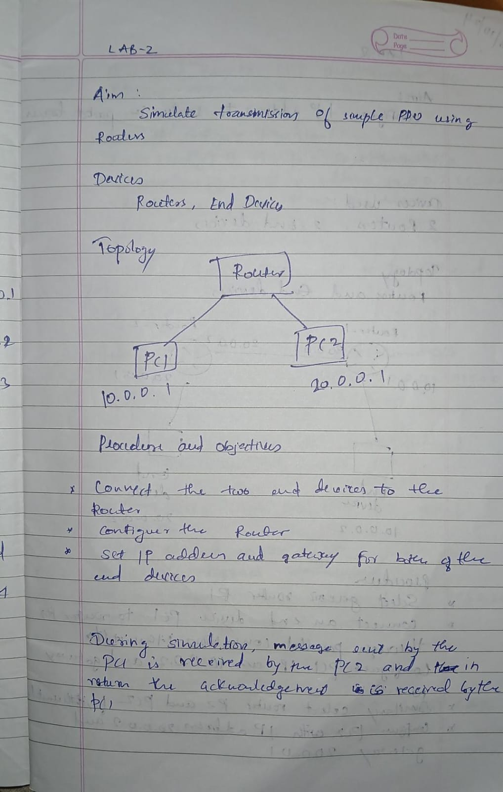

**Screen Shots:**

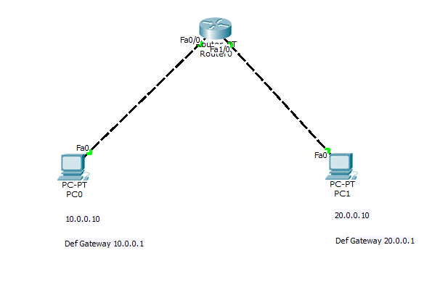

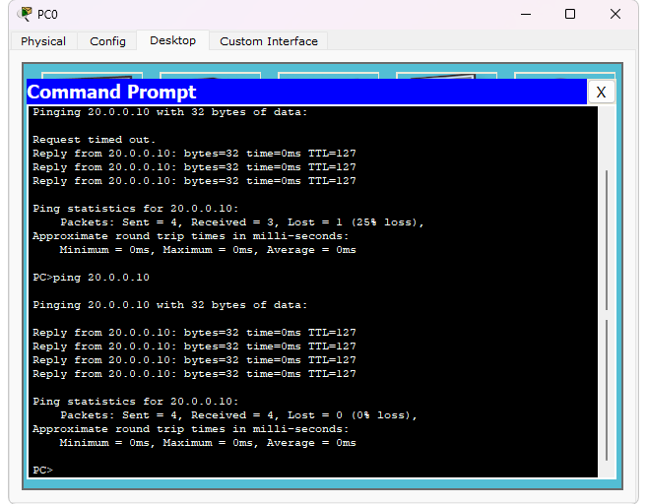

**Program 3**

**Aim:**Configure default route, static route to the Router(Part 1).

**Topology , Procedure and Observation:** 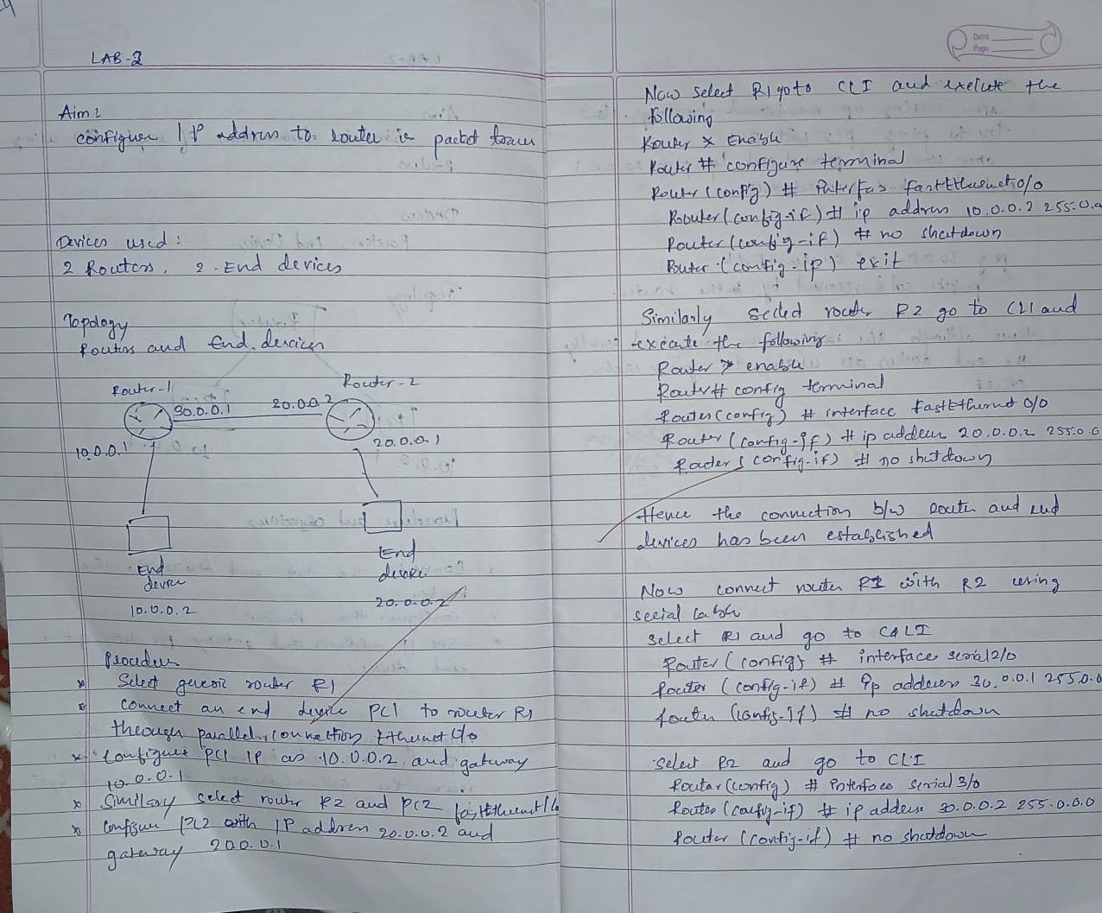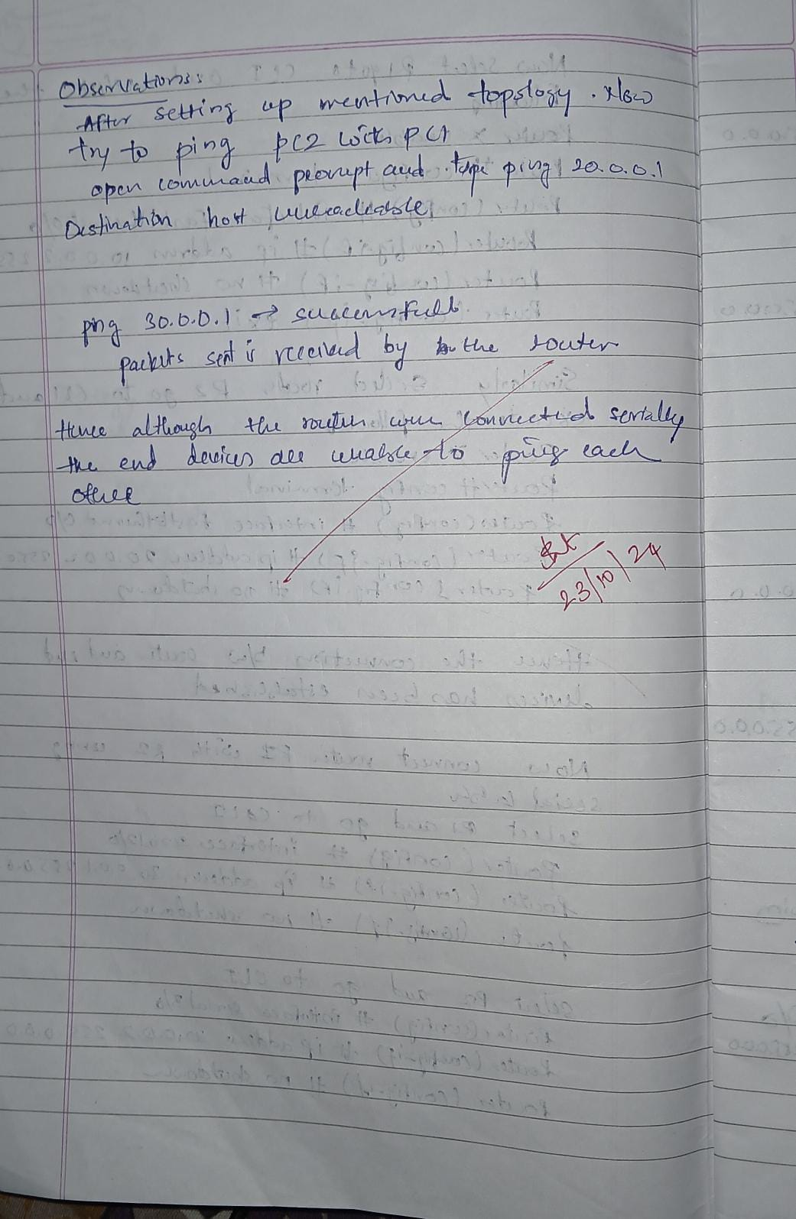

**Screen Shots:**

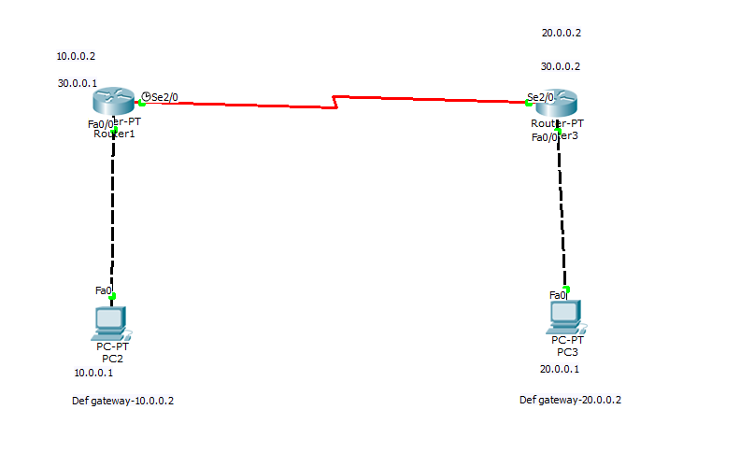

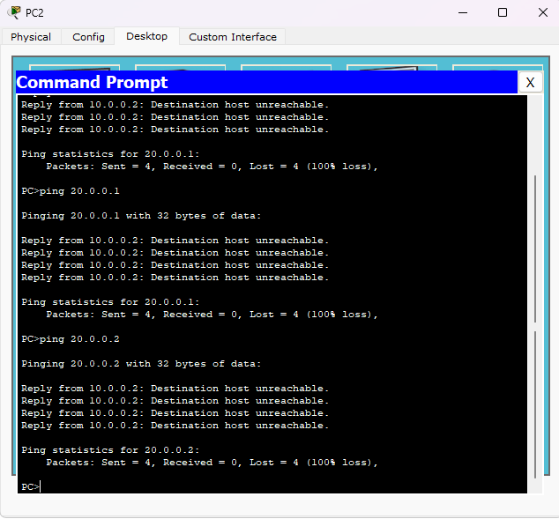

**Program 4**

**Aim:**Configure default route, static route to the Router(Part 2).

**Topology , Procedure and Observation:**

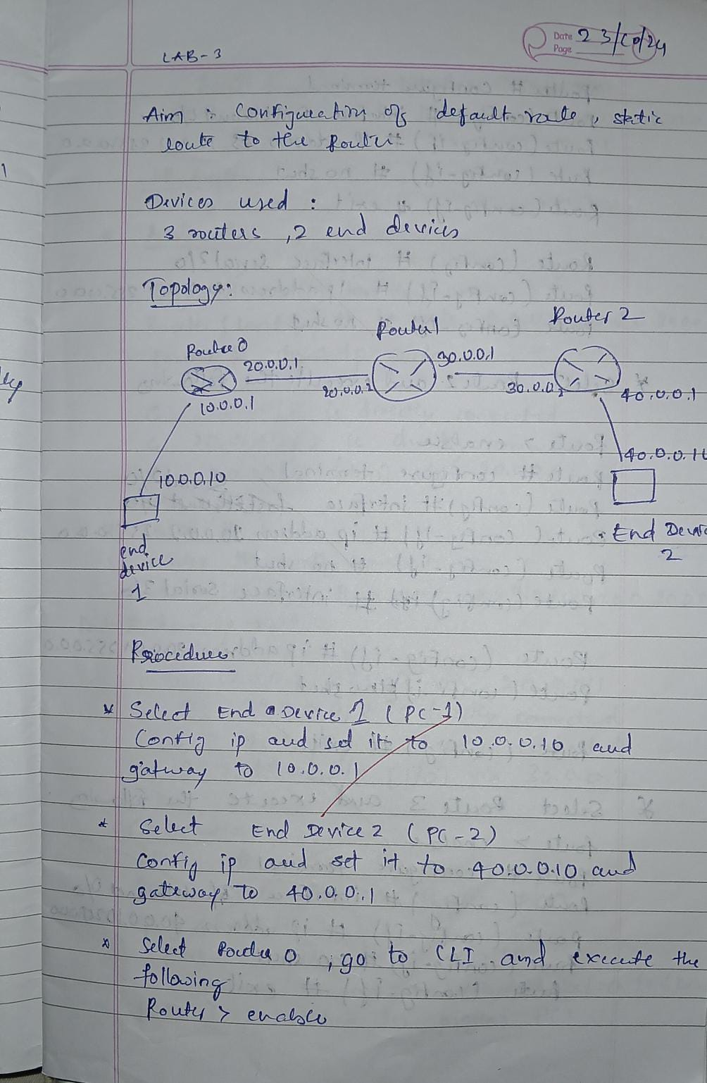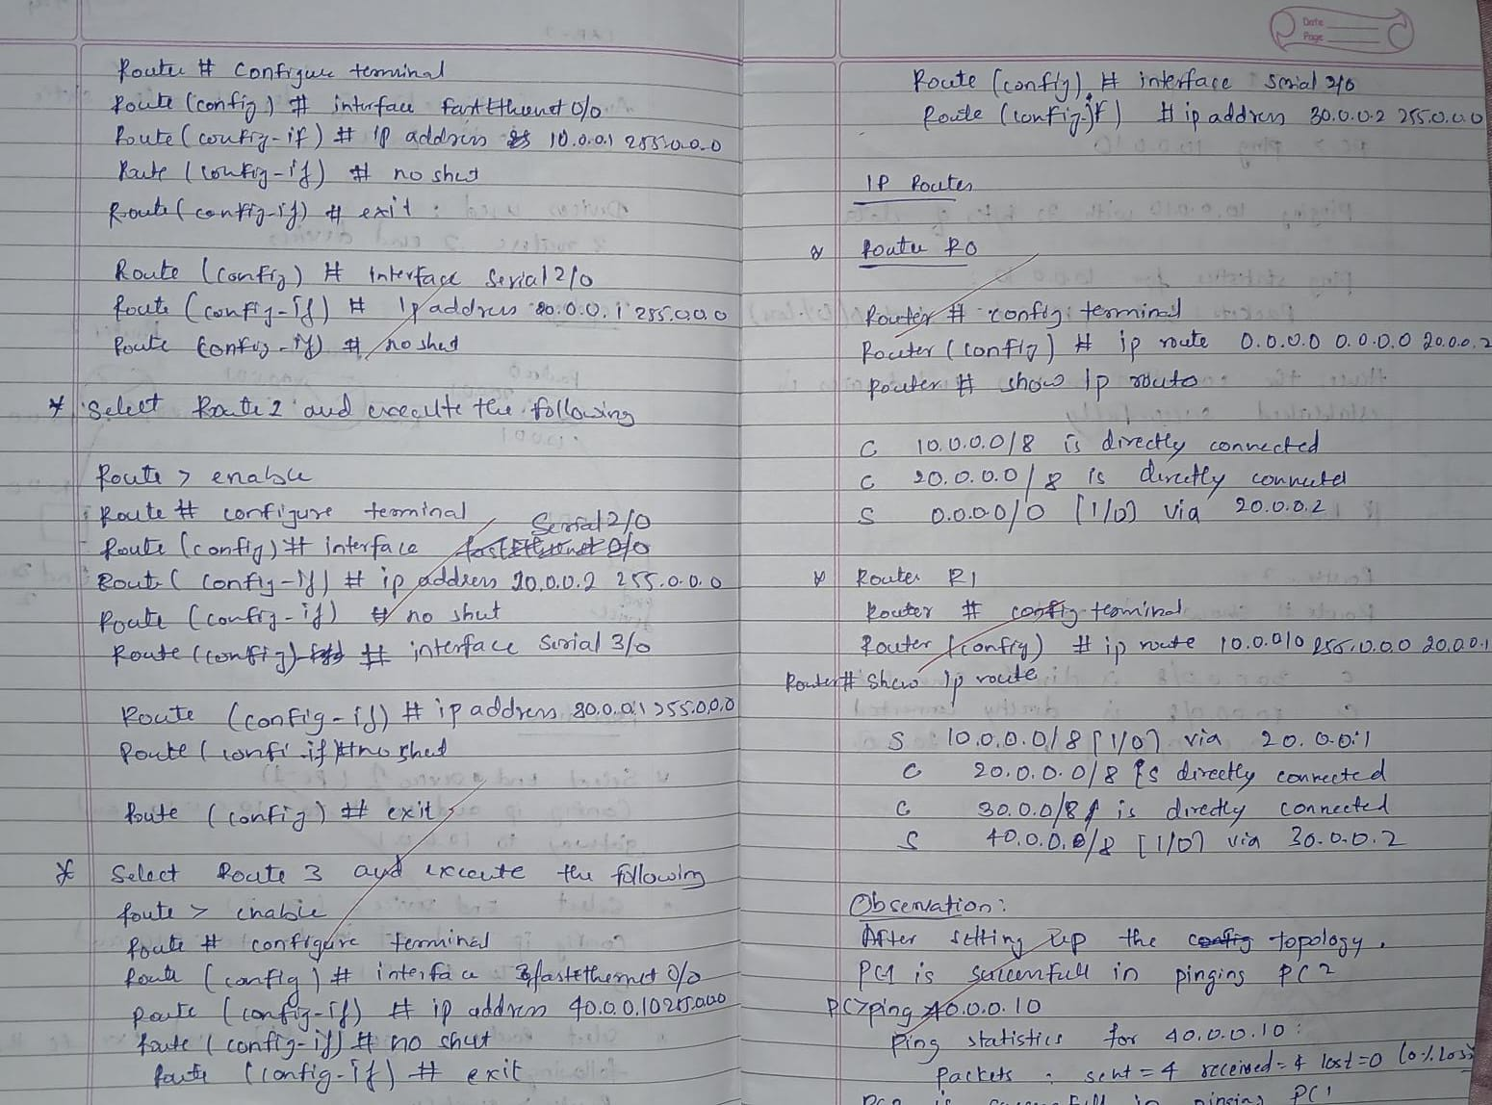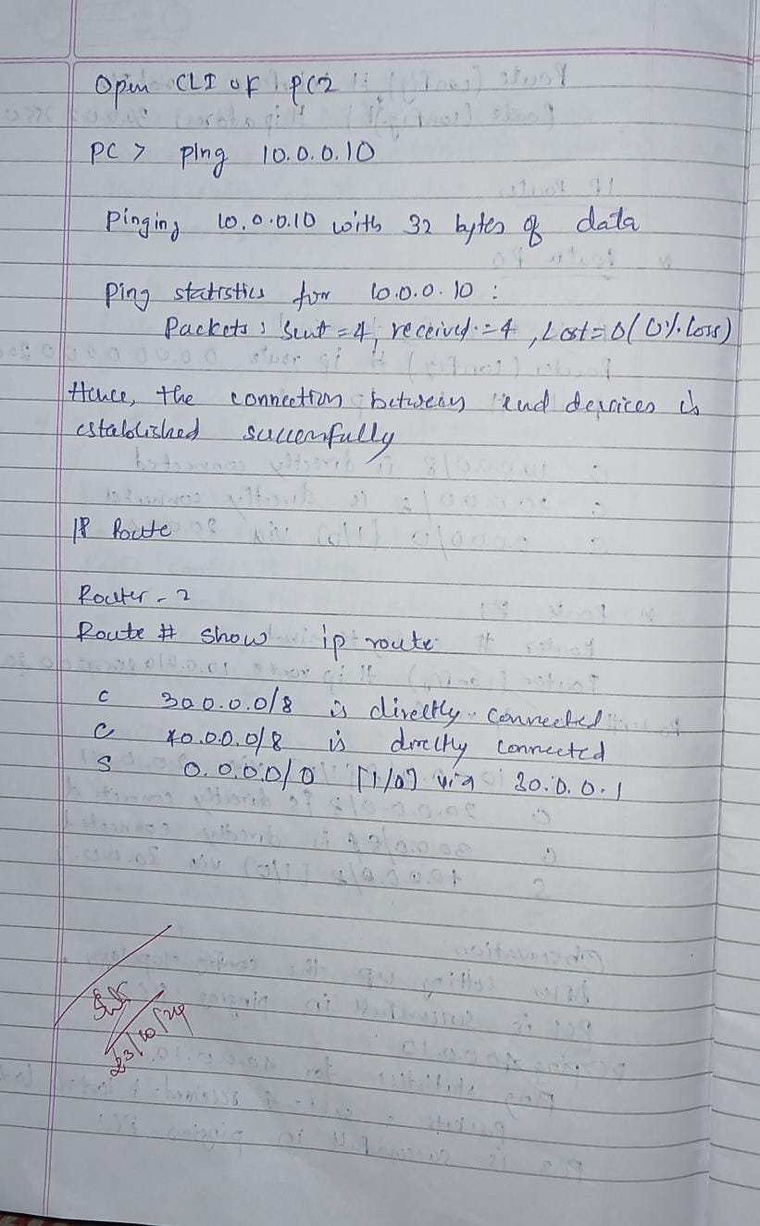

**Screen Shots:**

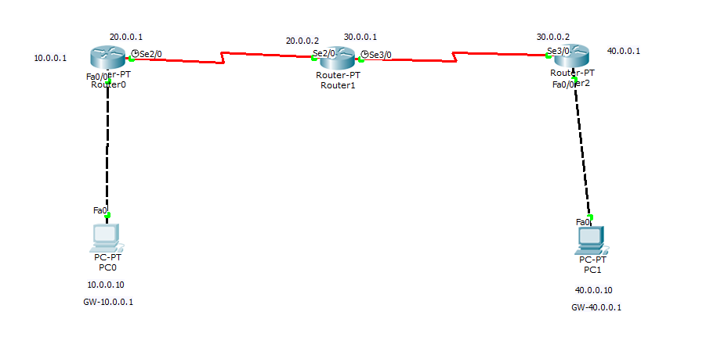

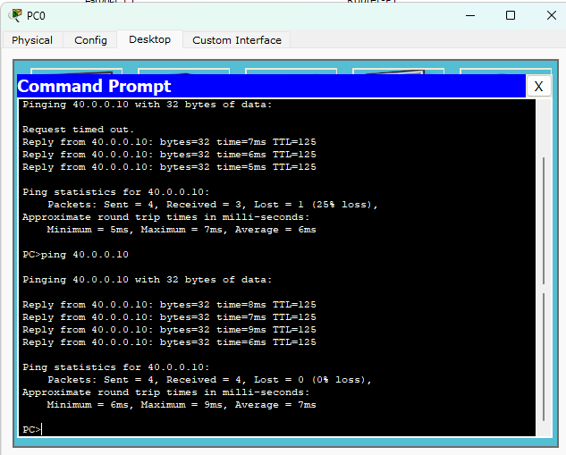

**Program 5**

**Aim:** Configure DHCP within a LAN and outside LAN.

**Topology , Procedure and Observation:** 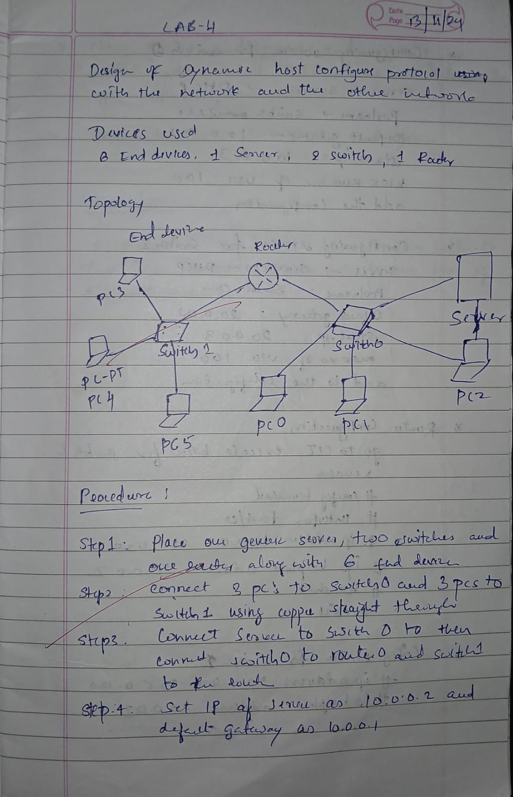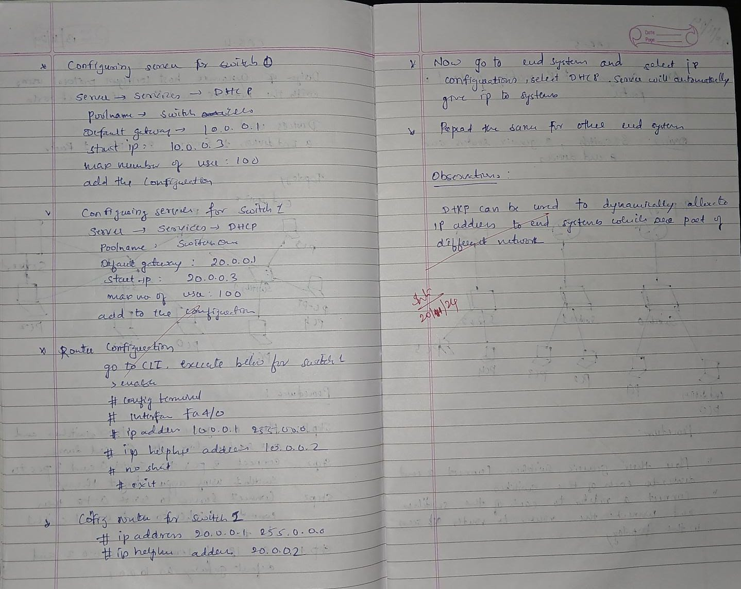

**Screen Shots:**

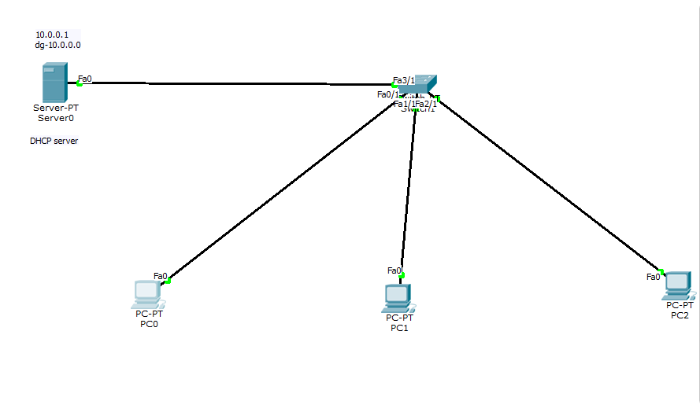

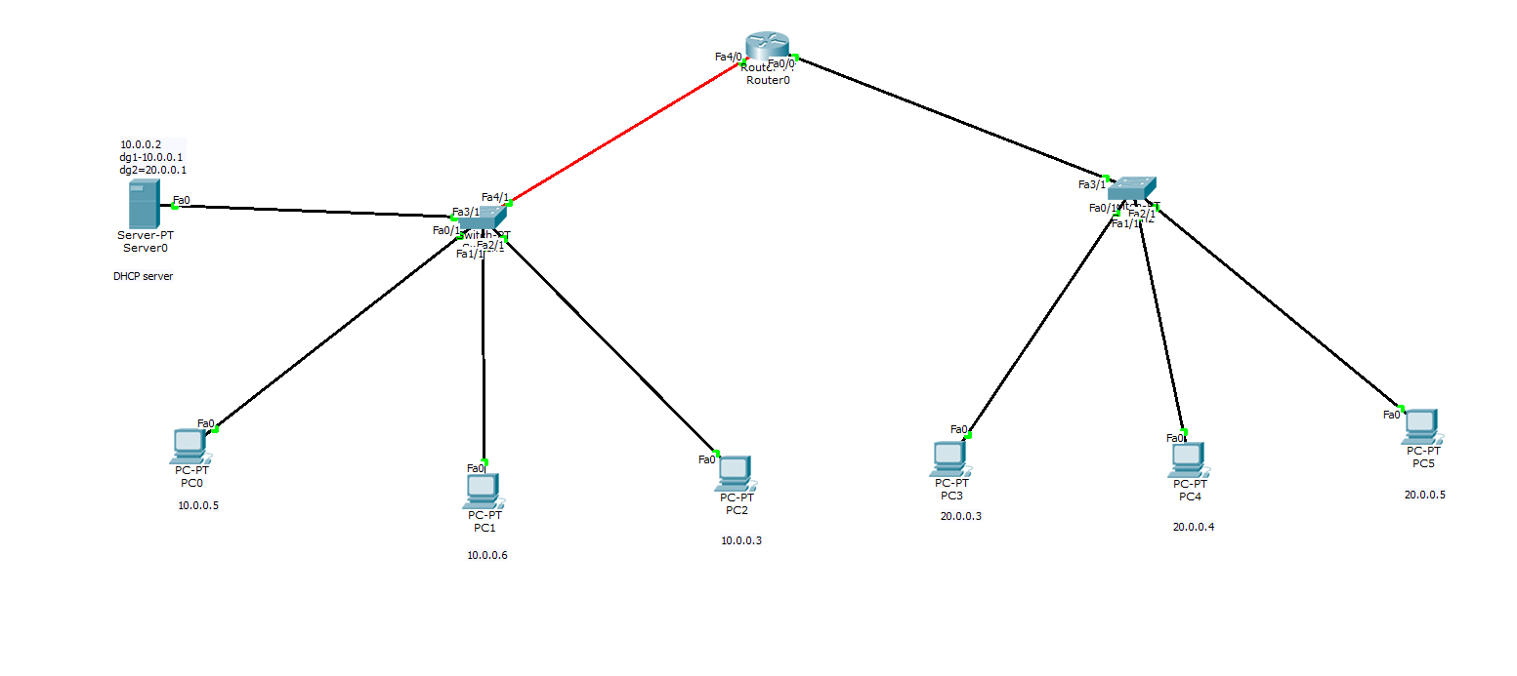

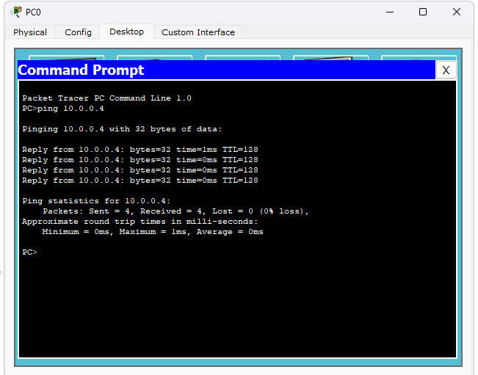

**Program 6**

**Aim:**Configure RIP routing Protocol in Routers .

**Topology , Procedure and Observation:** 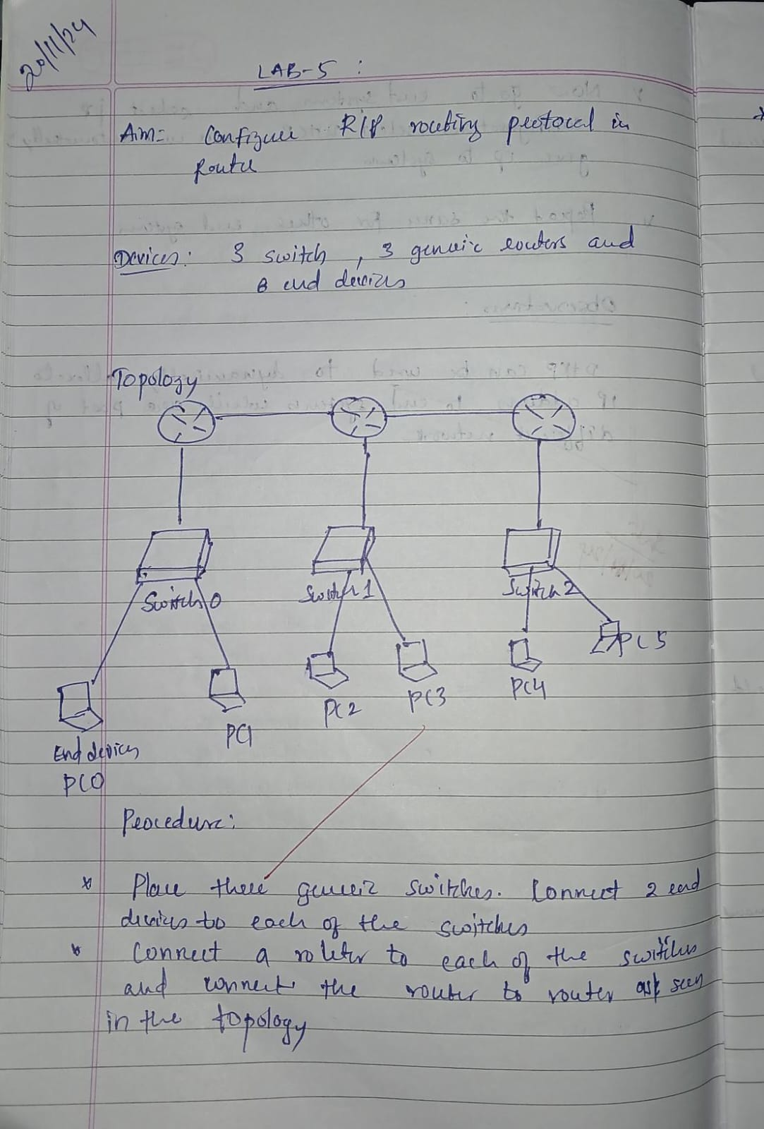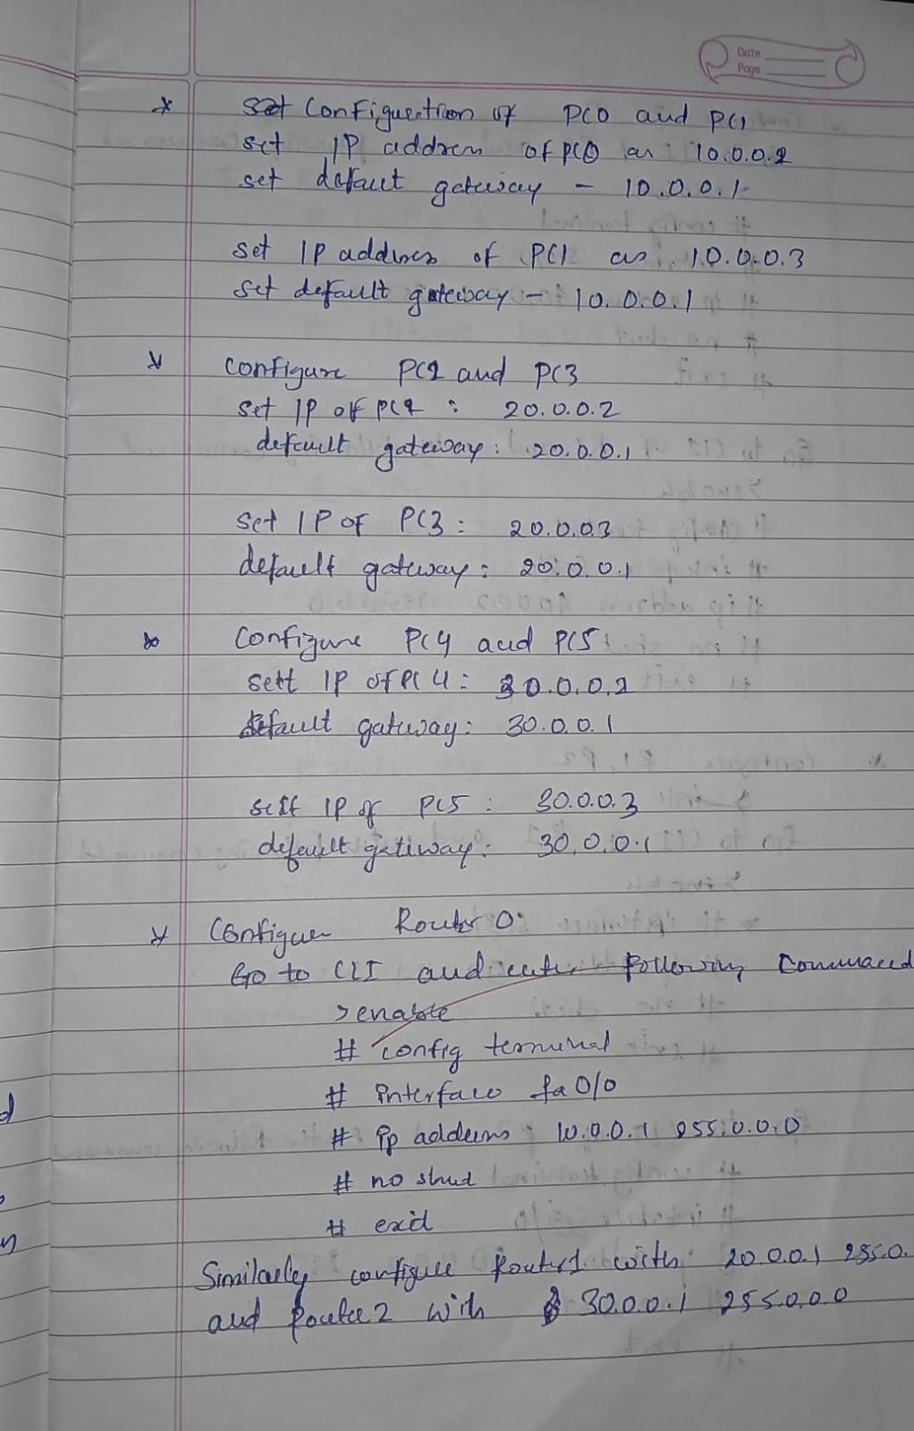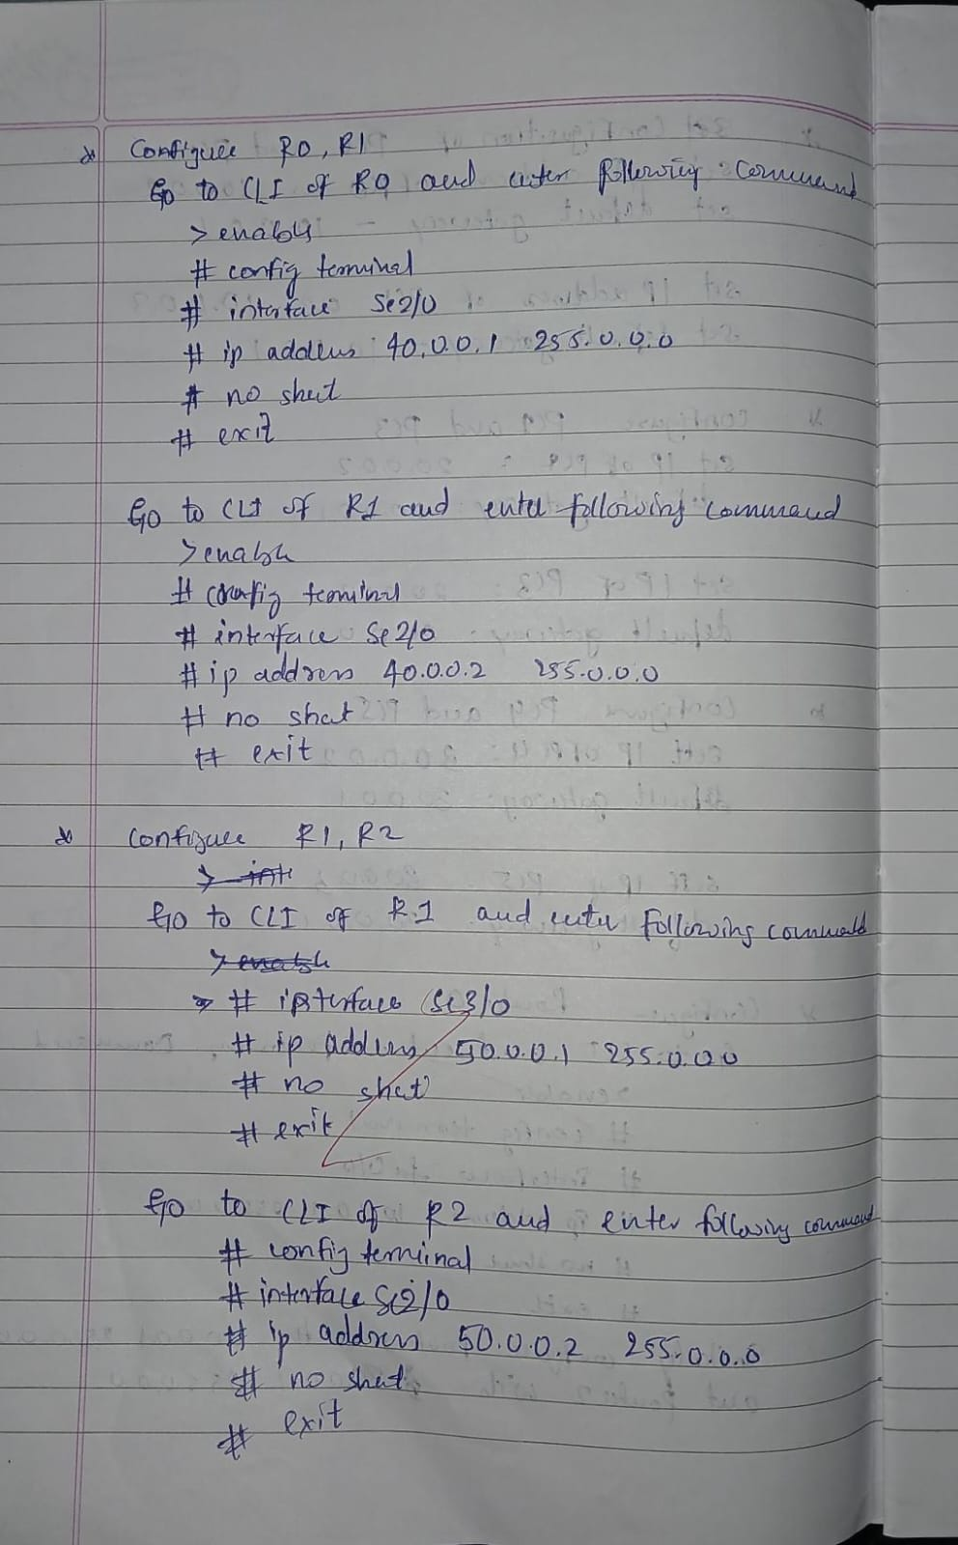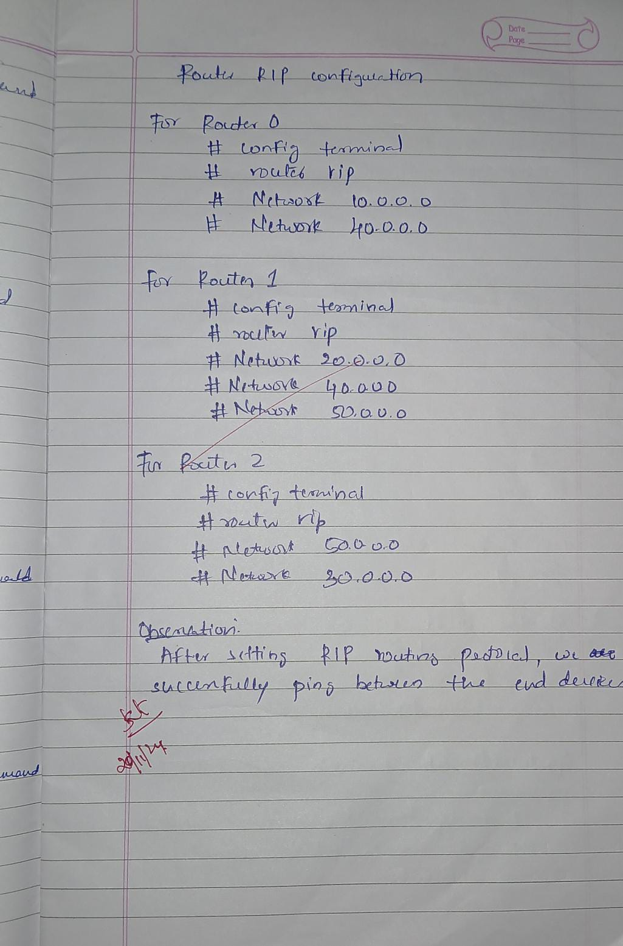

**Screen Shots:**

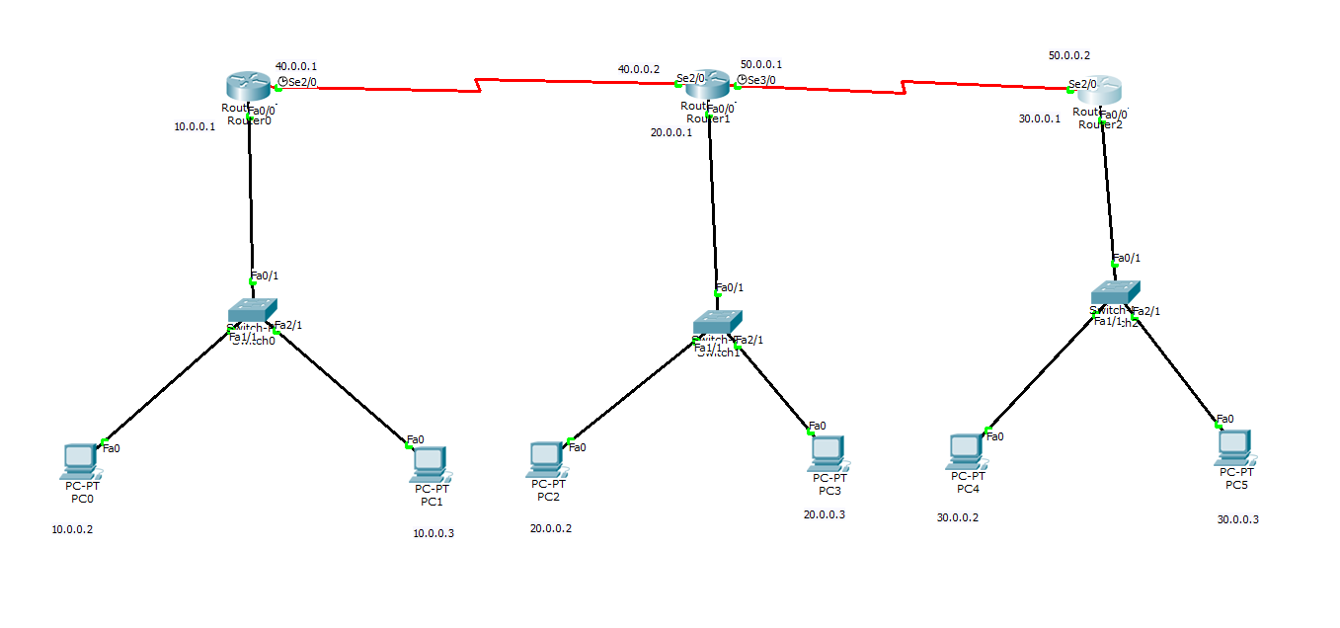

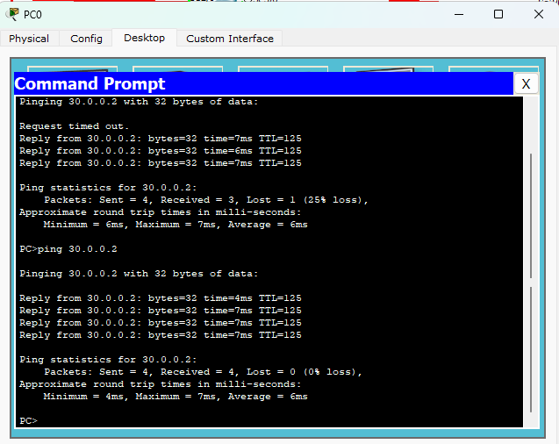

**Program 7**

**Aim:**Demonstrate the TTL/ Life of a Packet .

**Topology , Procedure and Observation:**

**Screen Shots:**

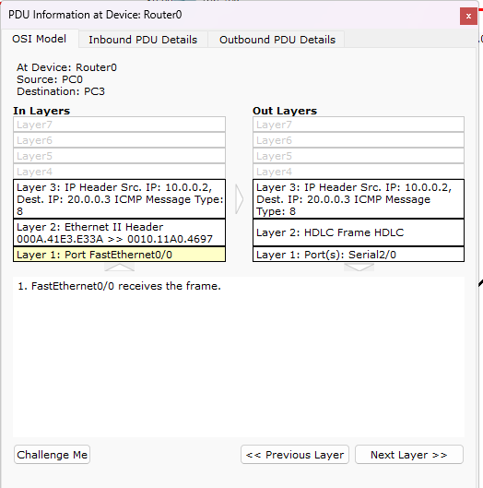

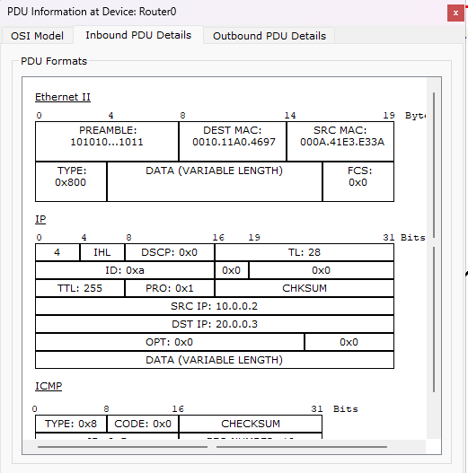

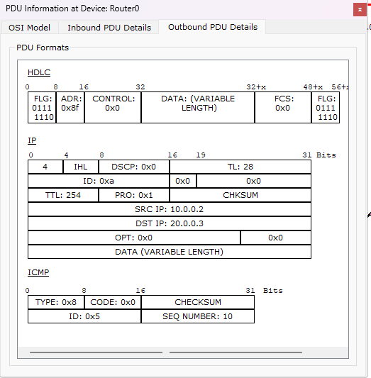

**Program 8**

**Aim:**Configure OSPF routing protocol .

**Topology , Procedure and Observation:** 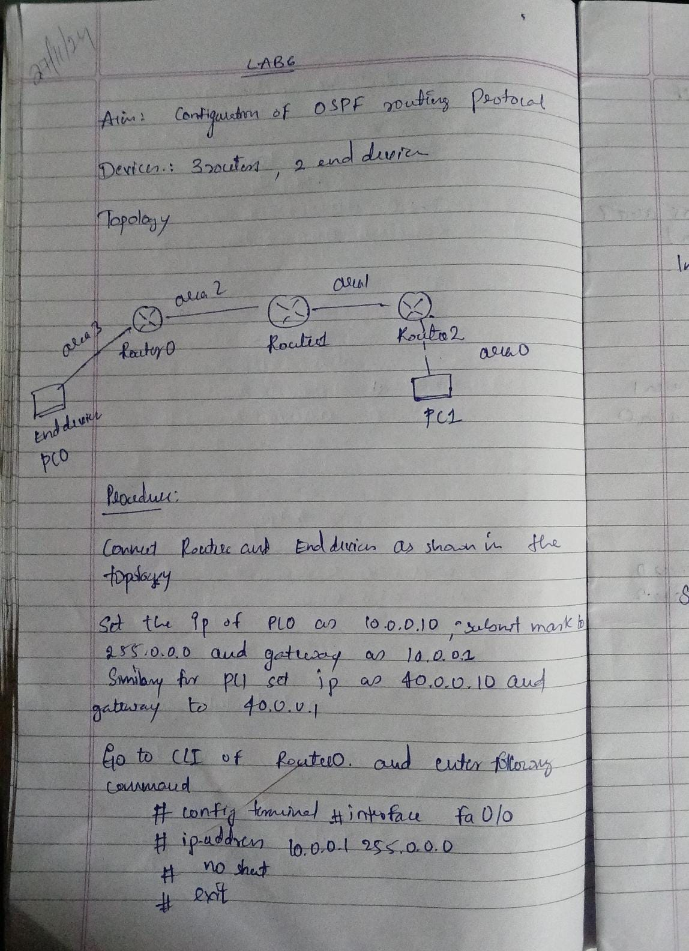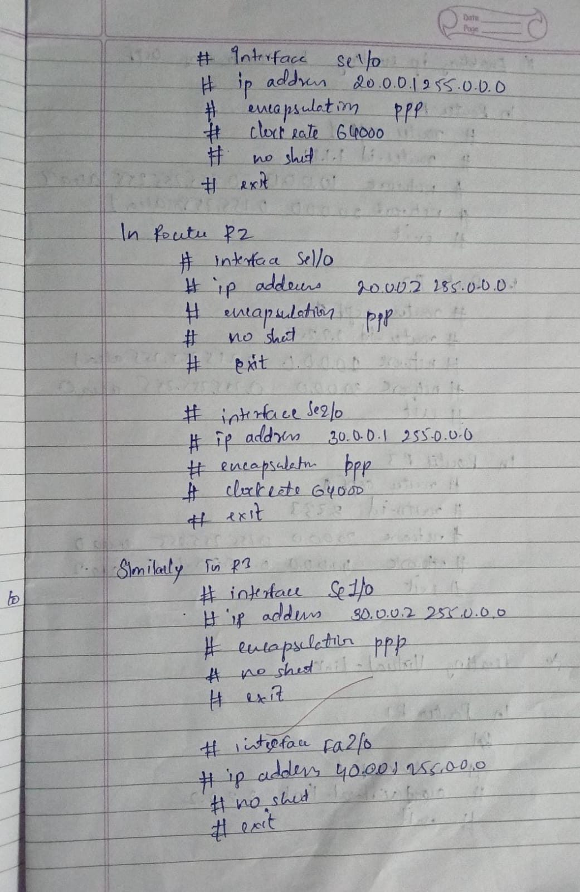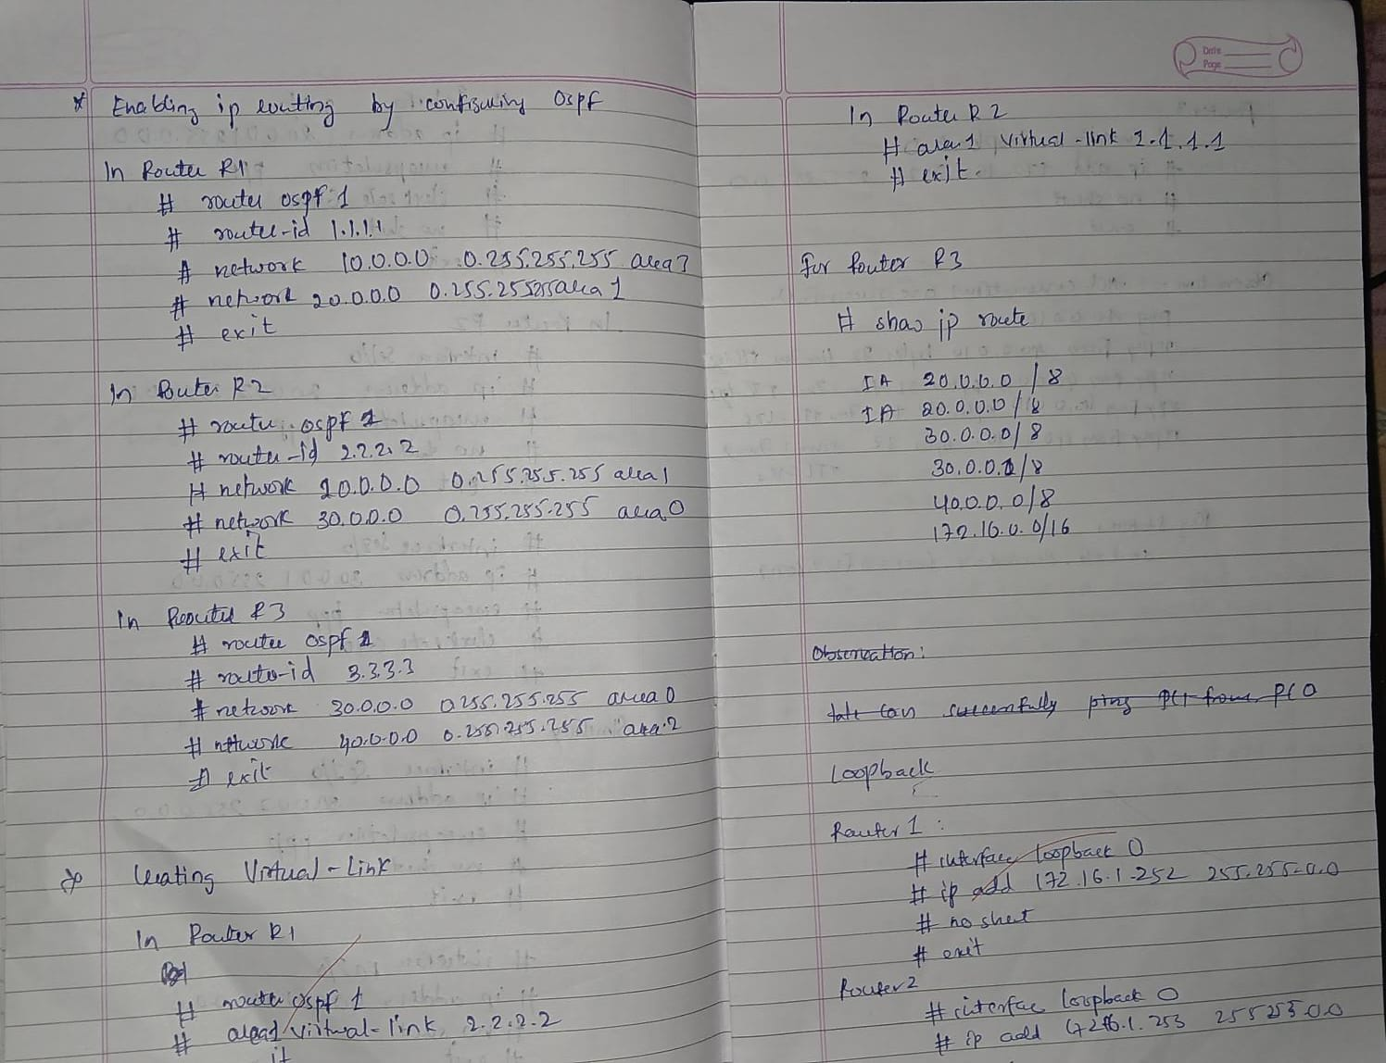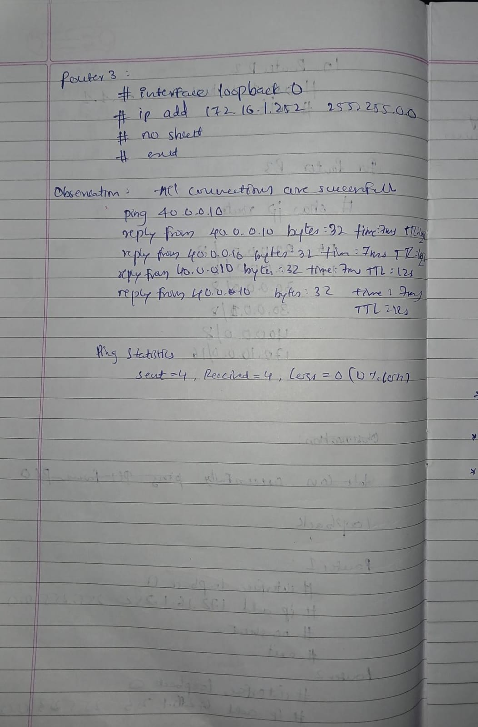

**Screen Shots:**

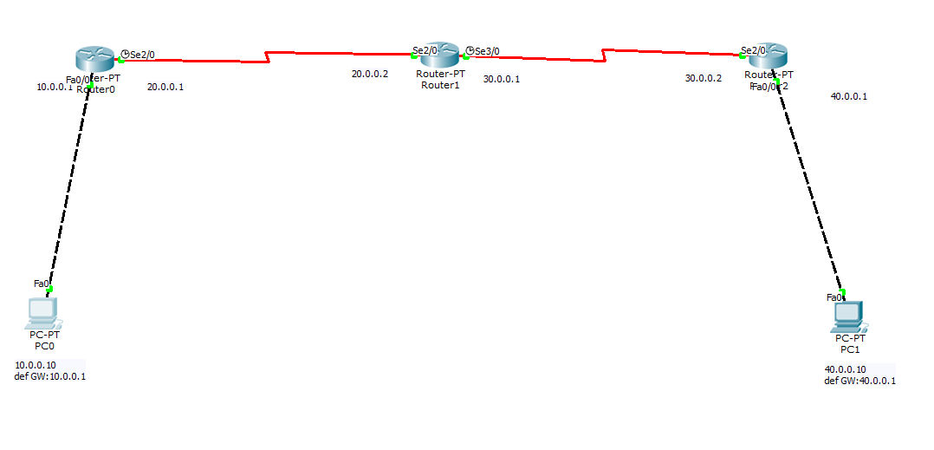

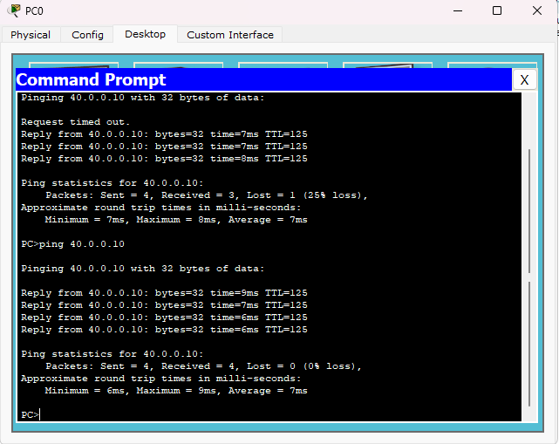

**Program 9**

**Aim:**Configure Web Server, DNS within a LAN.

**Topology , Procedure and Observation:** 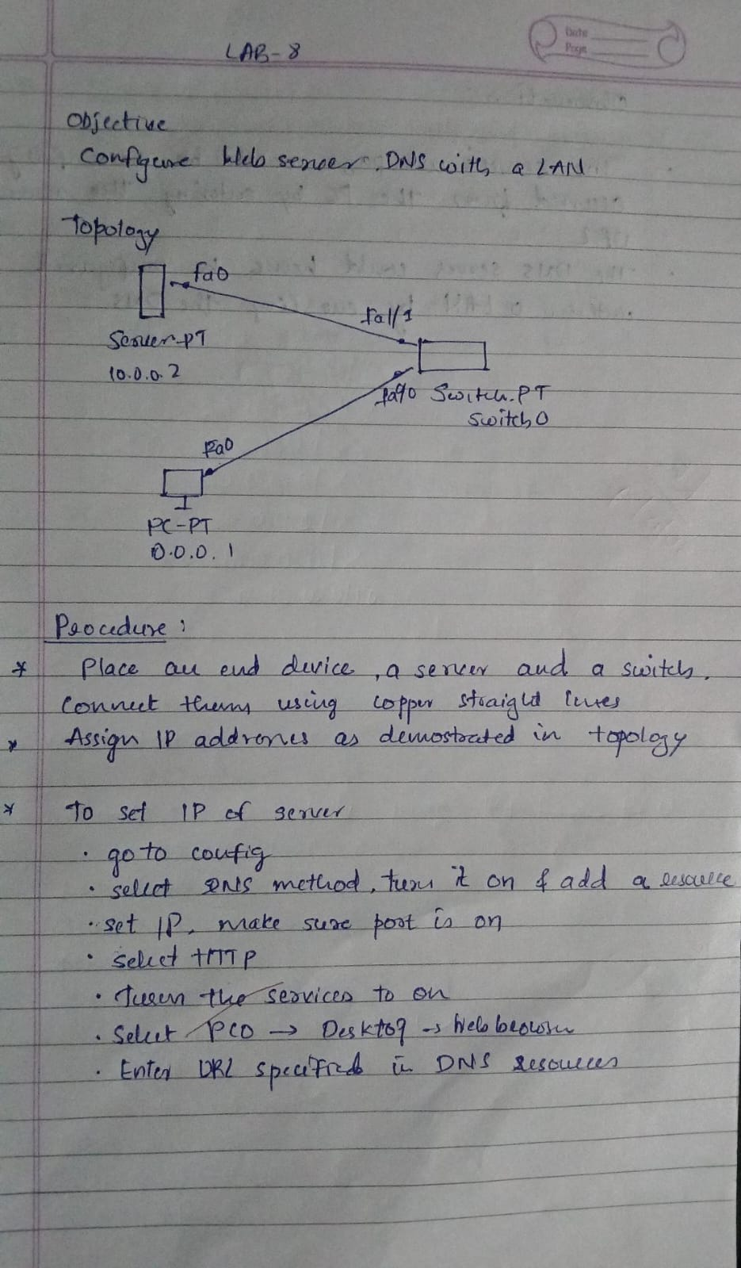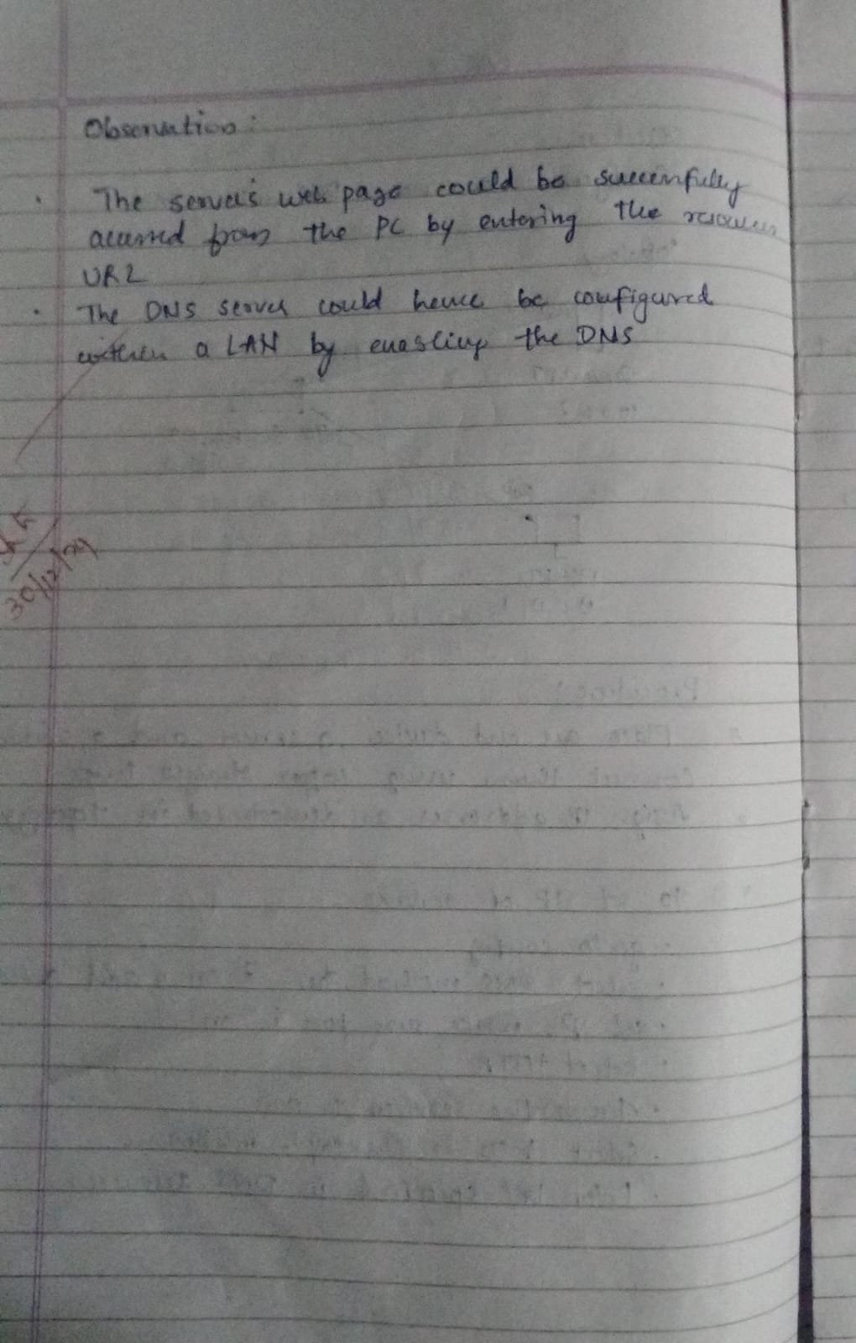

**Screen Shots:**

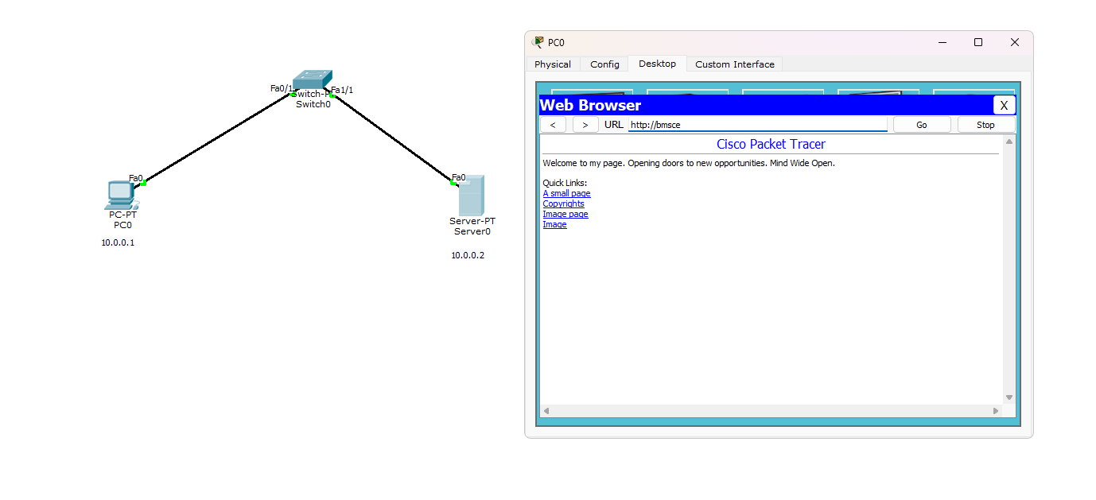

**Program 10**

**Aim:**To construct simple LAN and understand the concept and operation of Address Resolution Protocol (ARP)

**Topology , Procedure and Observation:** 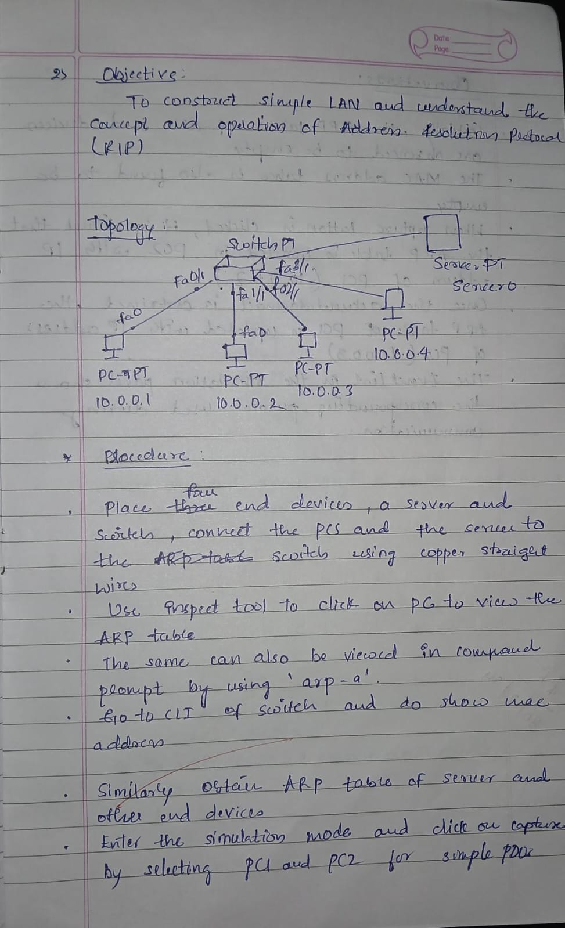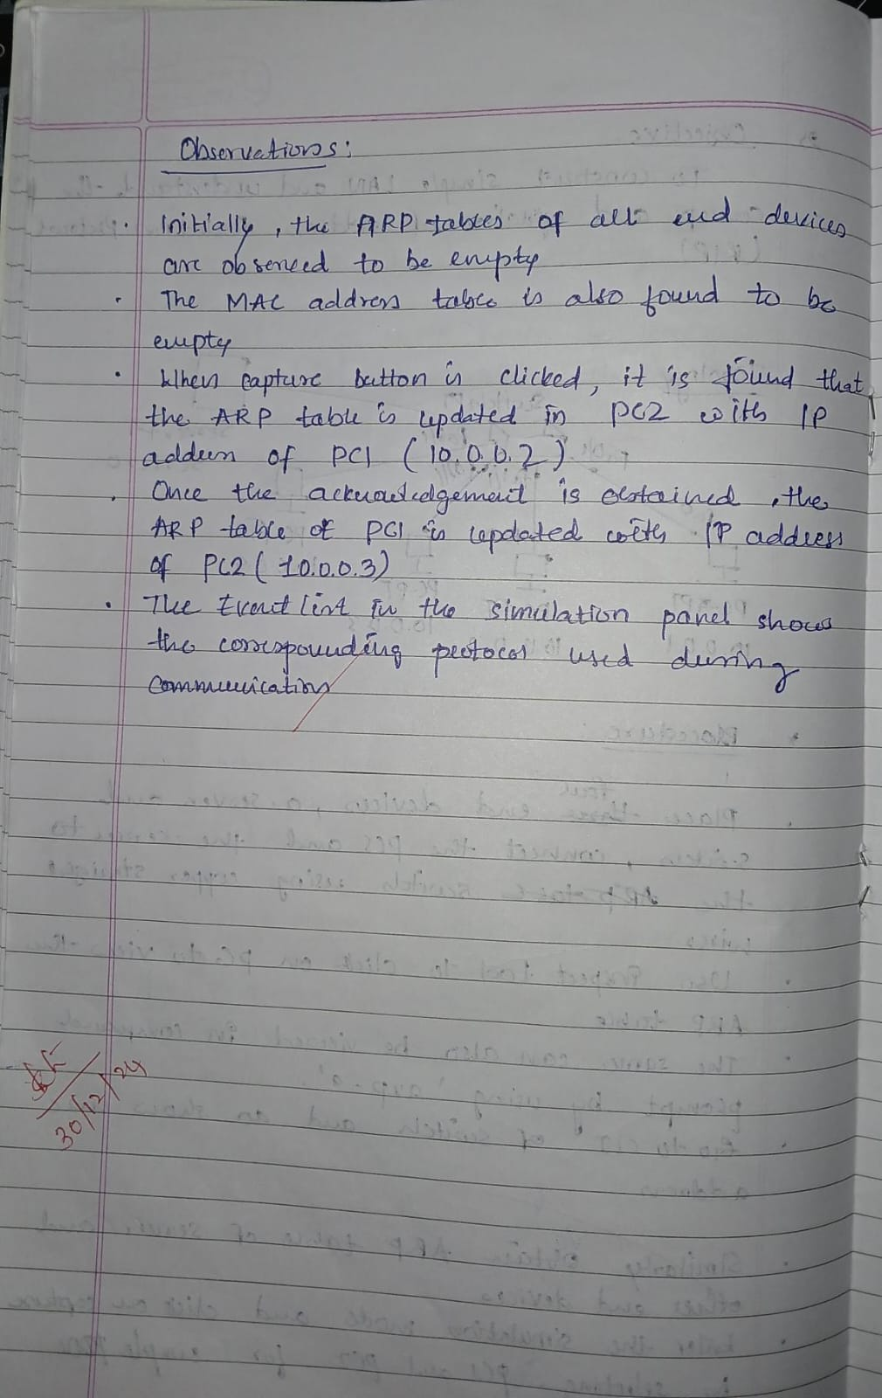

**Screen Shots:**

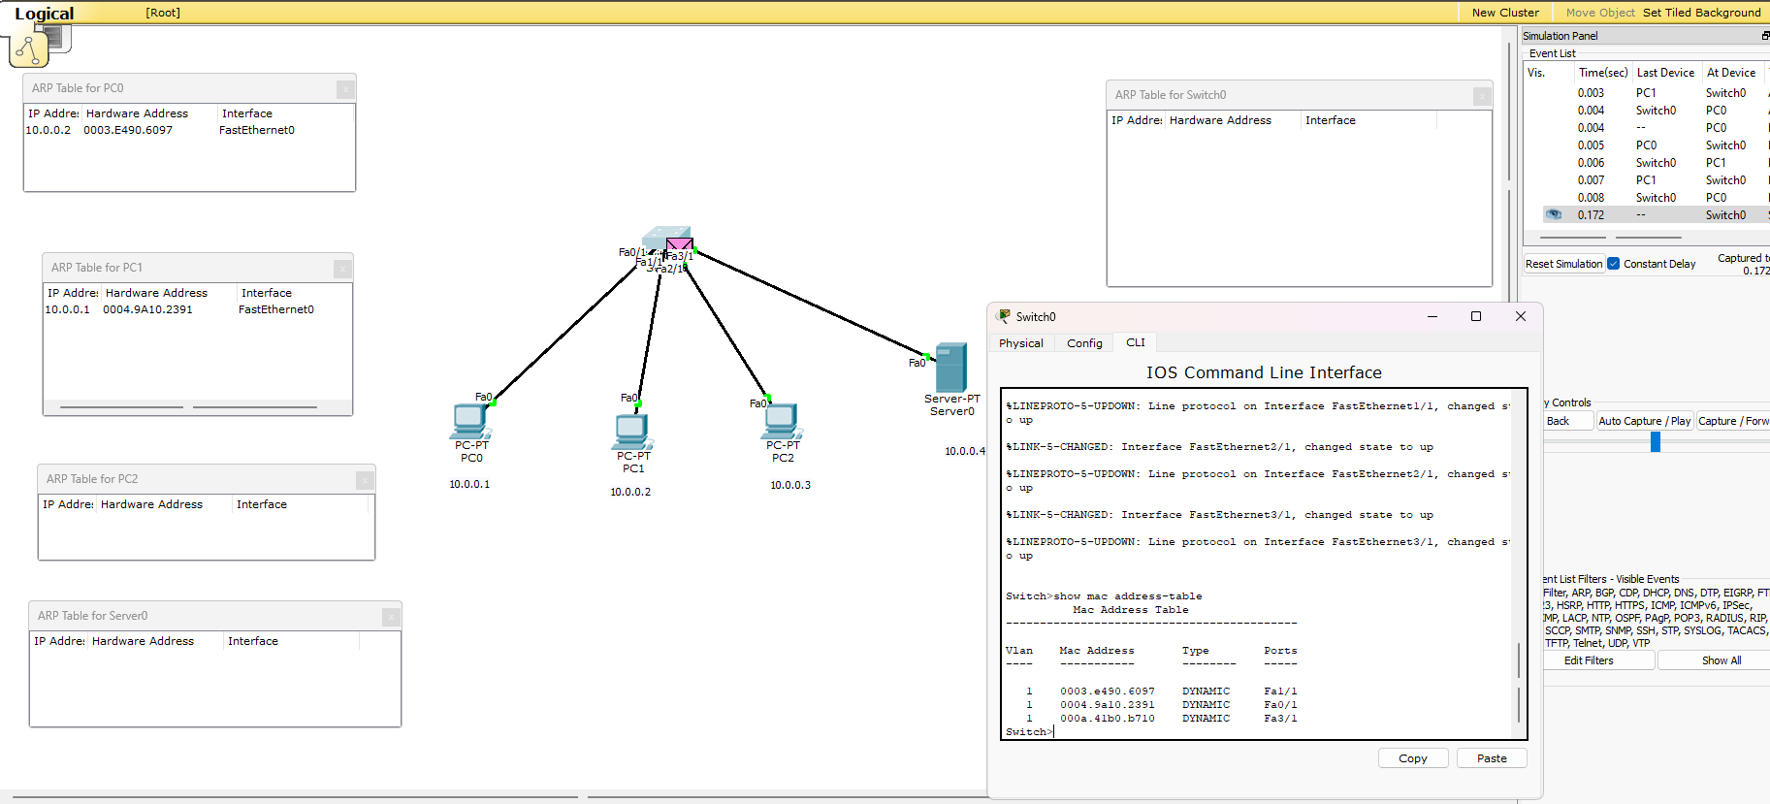

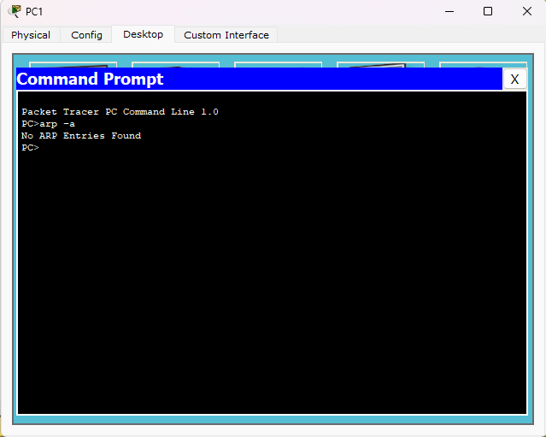

**Program 11**

**Aim:**To understand the operation of TELNET by accessing the router in the server room from a PC in the IT office.

**Topology , Procedure and Observation:** 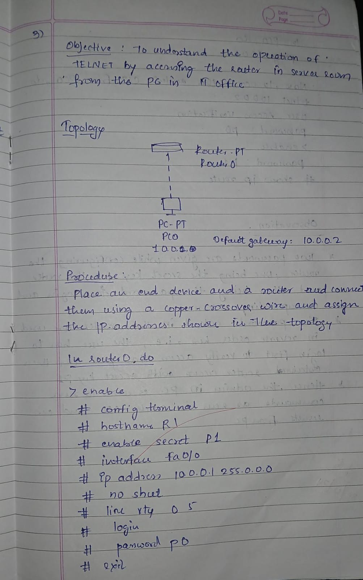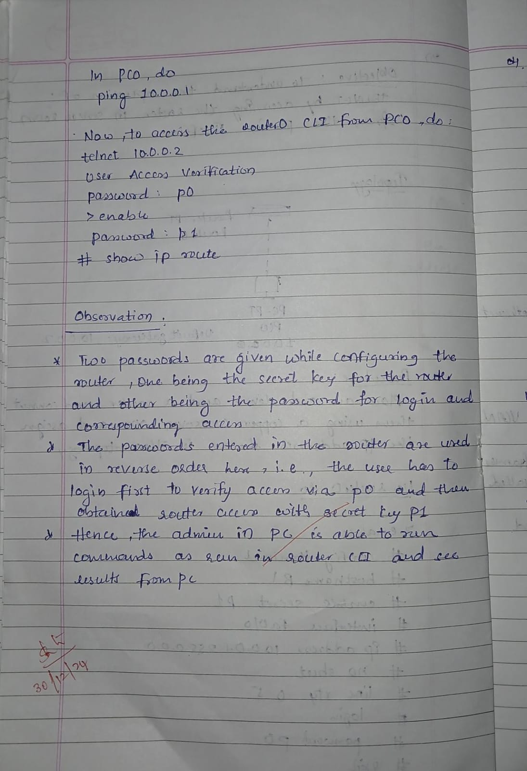

**Screen Shots:**

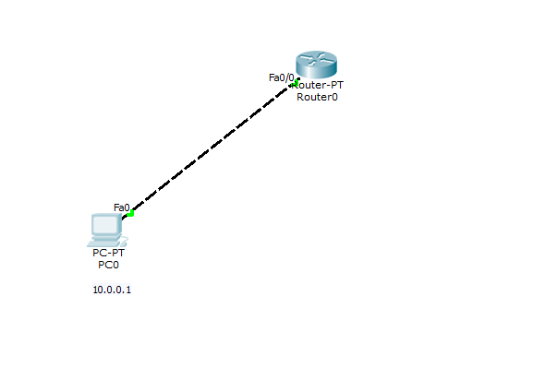

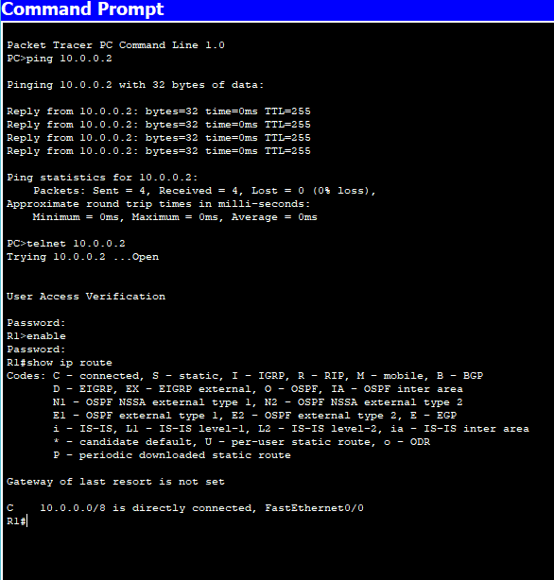

**Program 12**

**Aim:**To construct a VLAN and make the PC’s communicate among a VLAN .

**Topology , Procedure and Observation:** 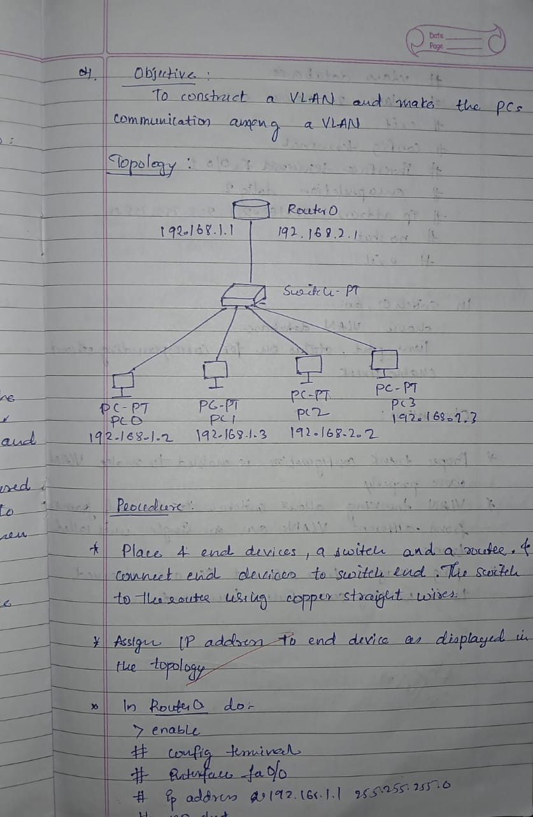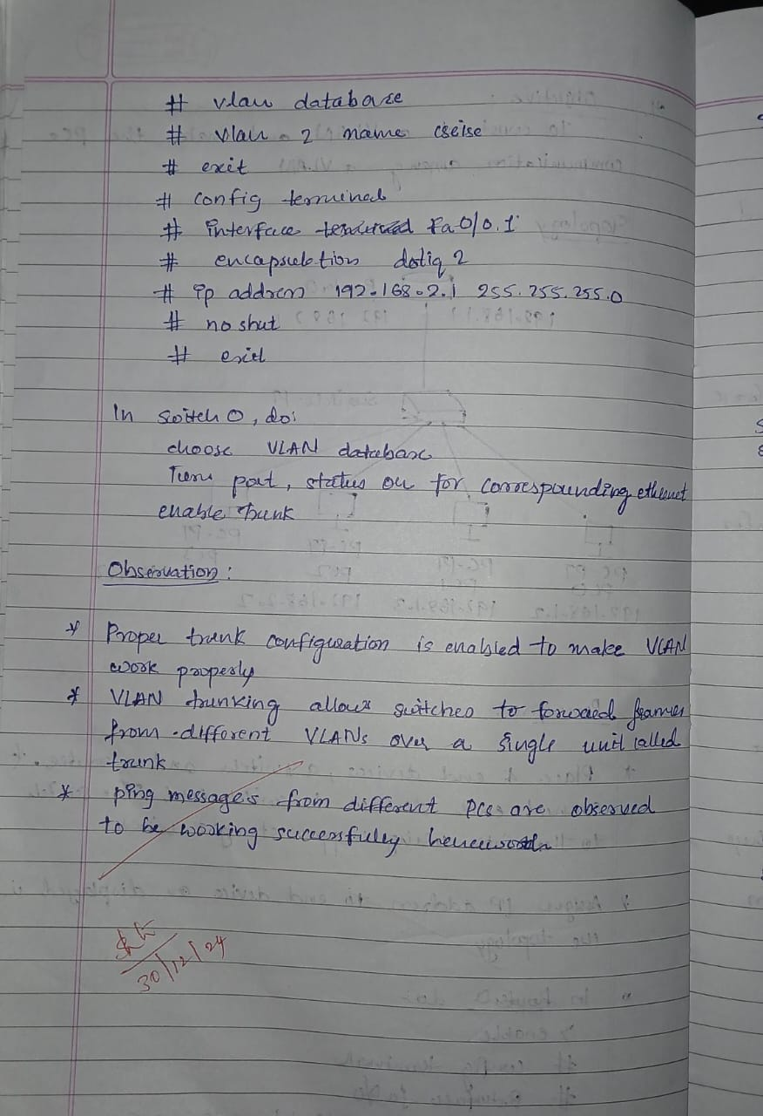

**Screen Shots:**

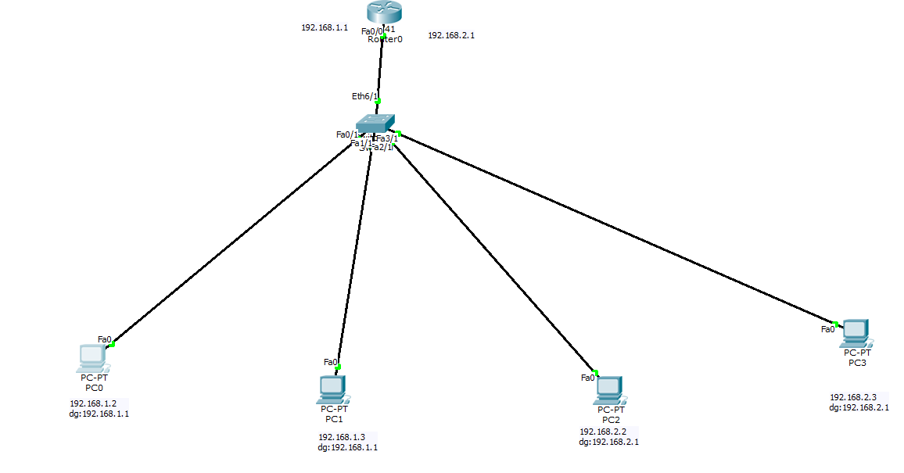

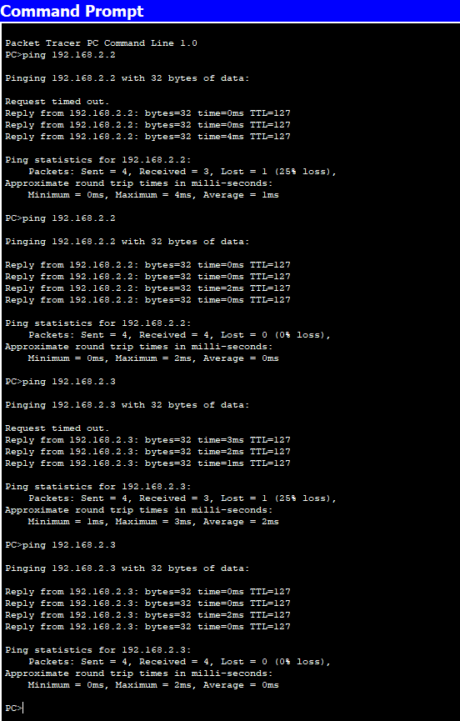

**Program 13**

**Aim:**To construct a WLAN and make the nodes communicate wirelessly.

**Topology , Procedure and Observation:** 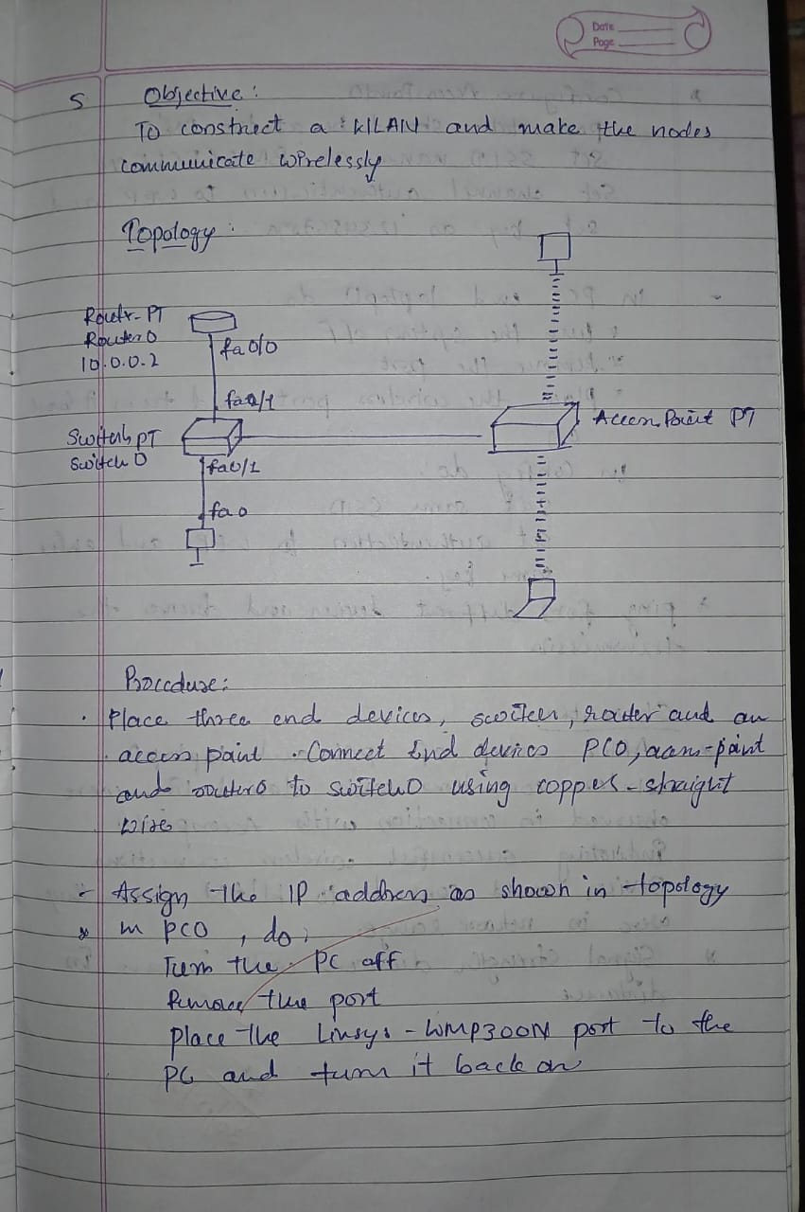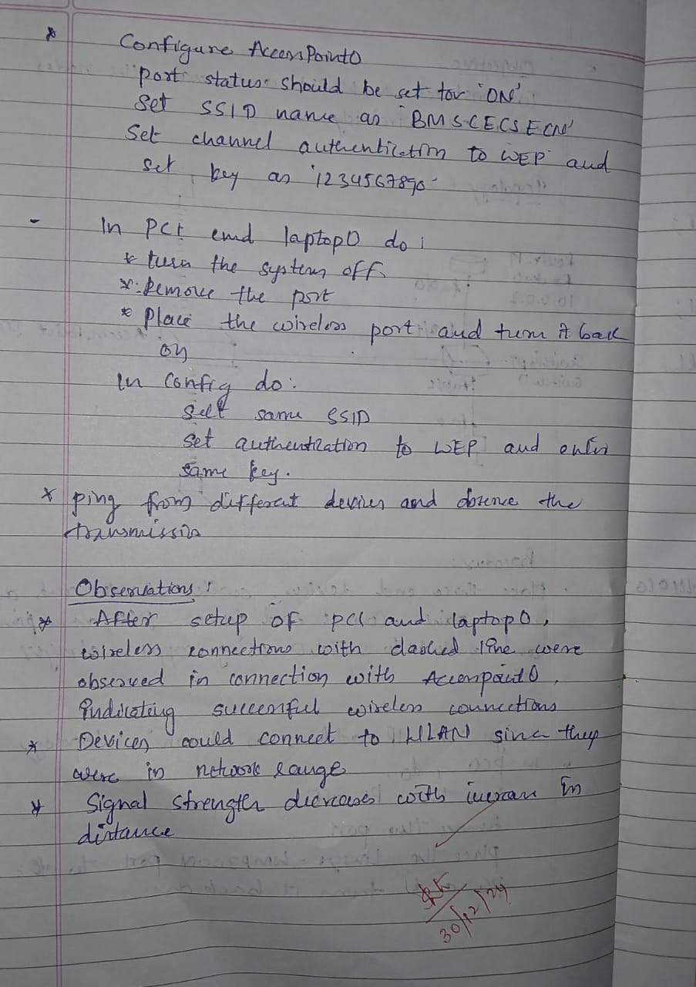

**Screen Shots:**

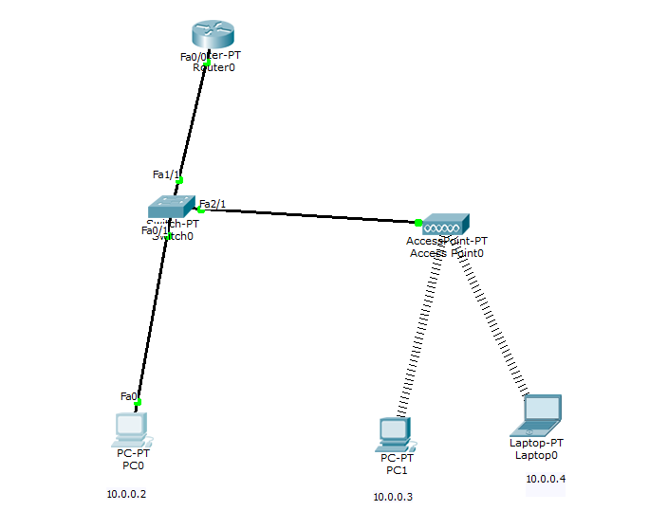

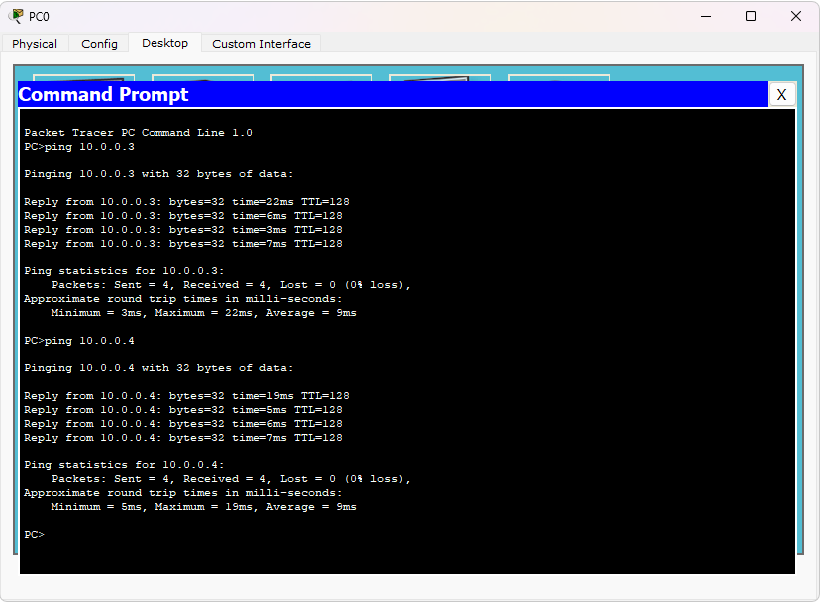

**PART-B**

**Program 14**

Write a program for error detecting code using CRC-CCITT (16-bits).

**Code and Output:** 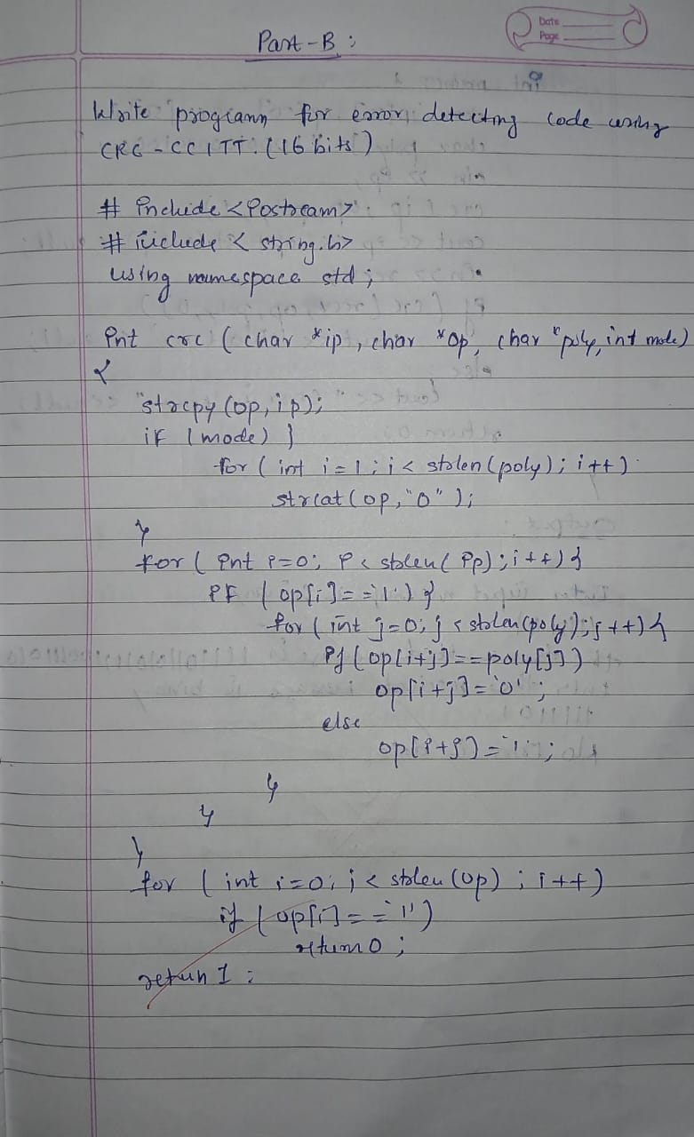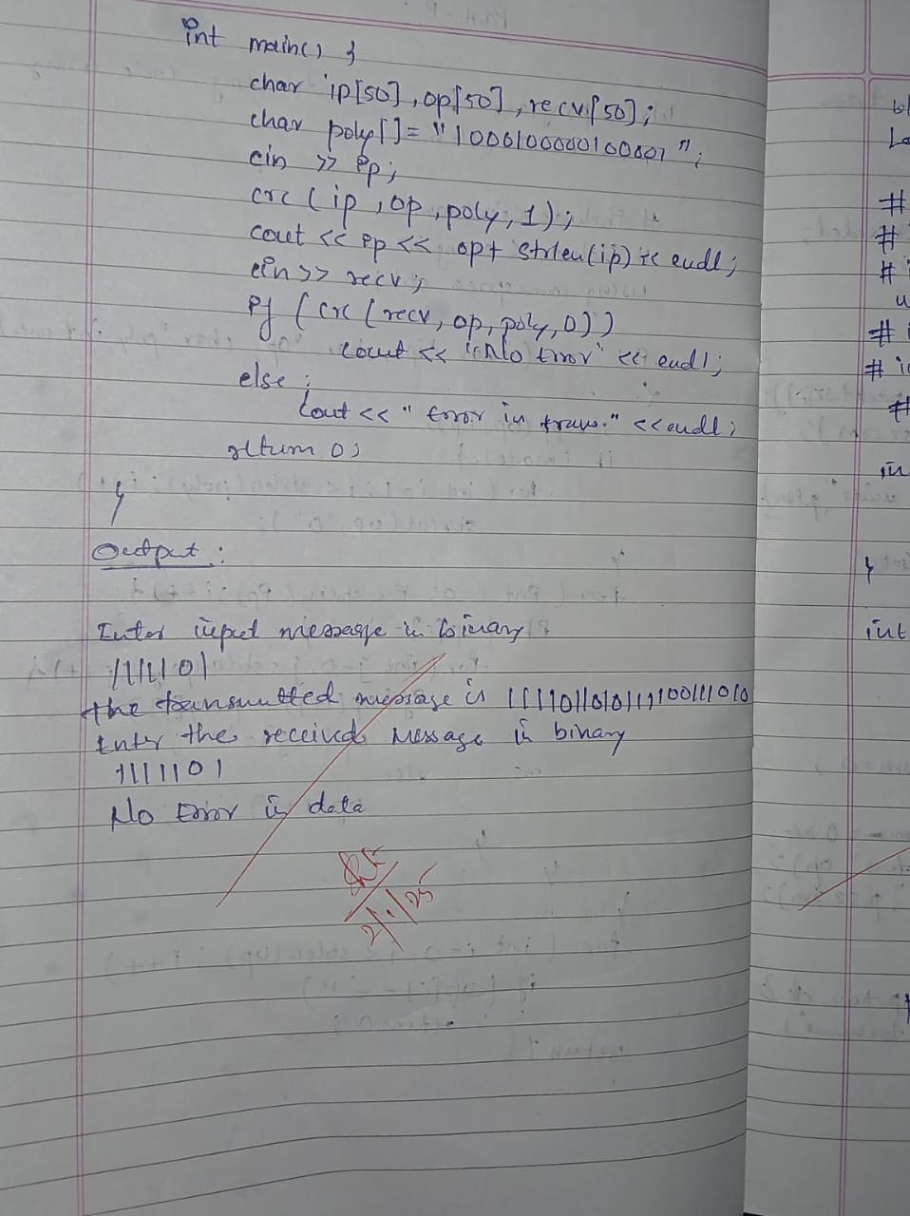

**Program 15**

Write a program for congestion control using Leaky bucket algorithm.

**Code and Output:** 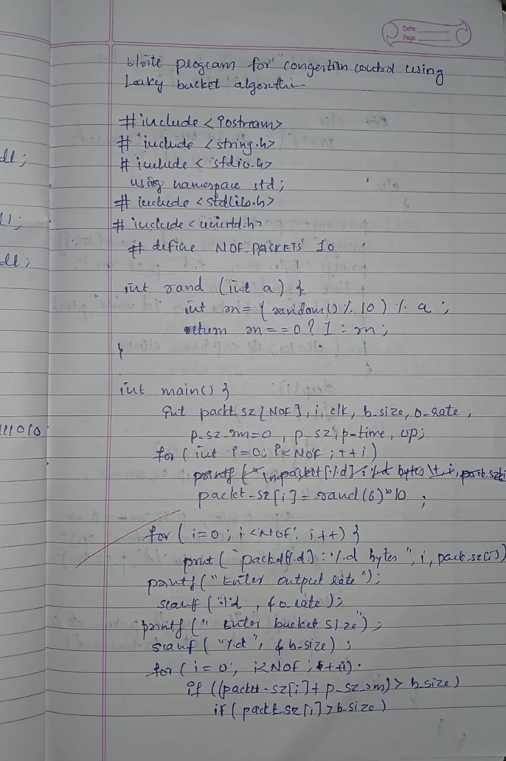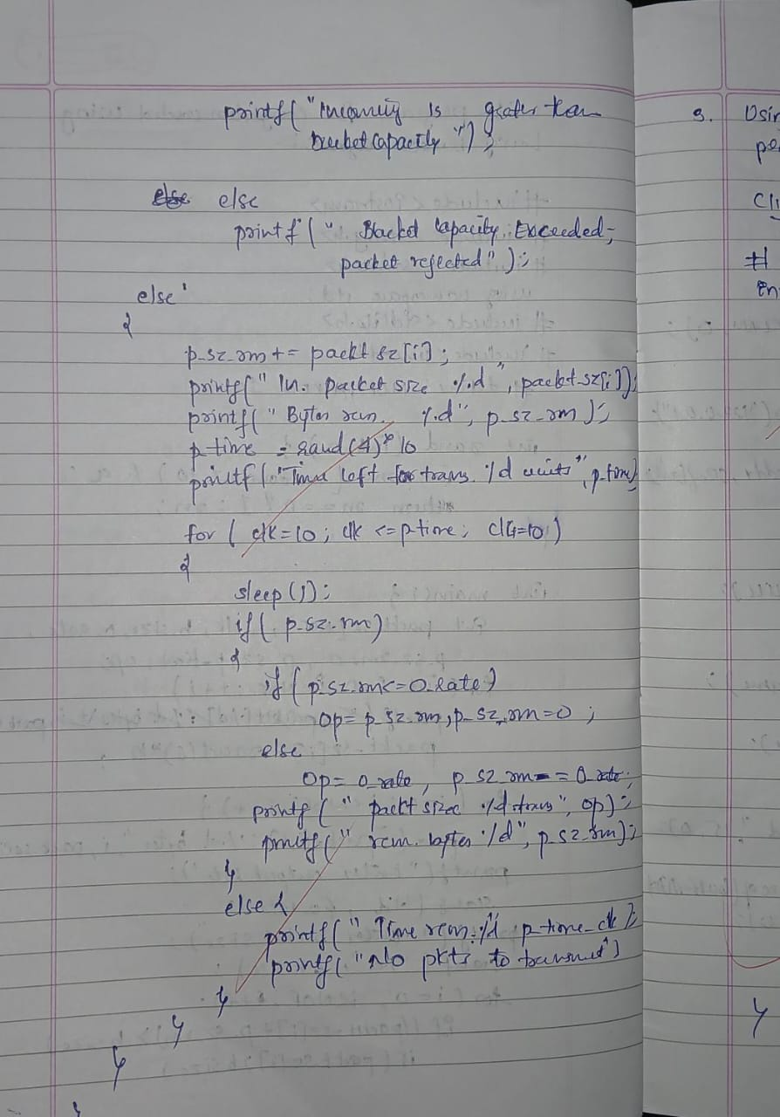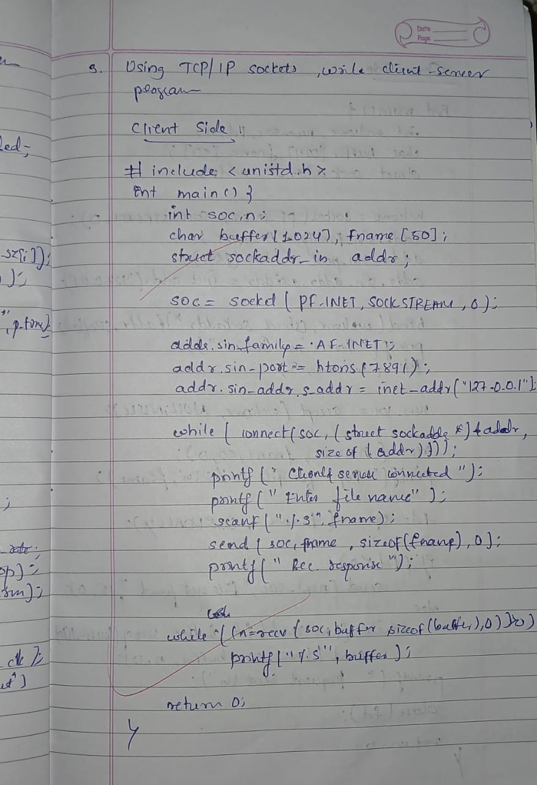

**Program 16**

Using TCP/IP sockets, write a client-server program to make the client send the file name and the server to send back the contents of the requested file if present.

**Code and Output:**

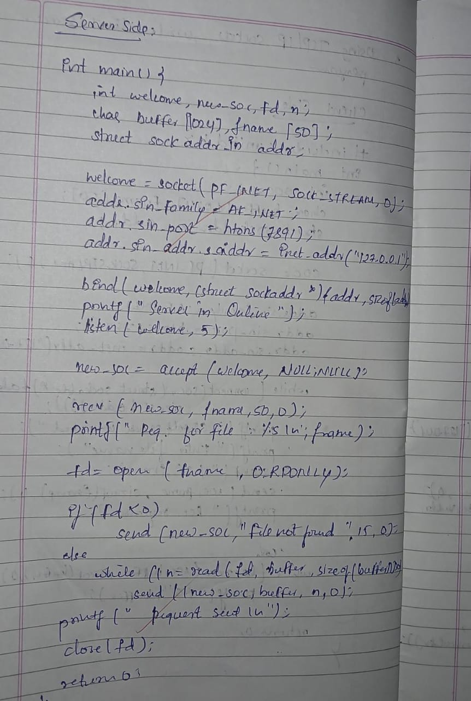

**Output:**

Server is online

Requesting for file: test.txt

Request sent

Client is connected to server

Enter file name: test.txt

Received response

Hello World

**Program 17**

Using UDP sockets, write a client-server program to make the client send the file name and the server to send back the contents of the requested file if present.

**Code and Output:** 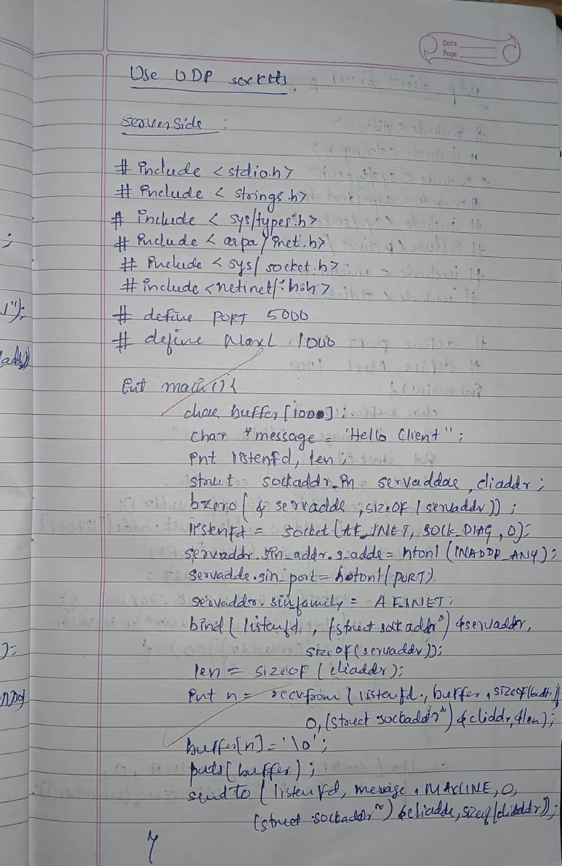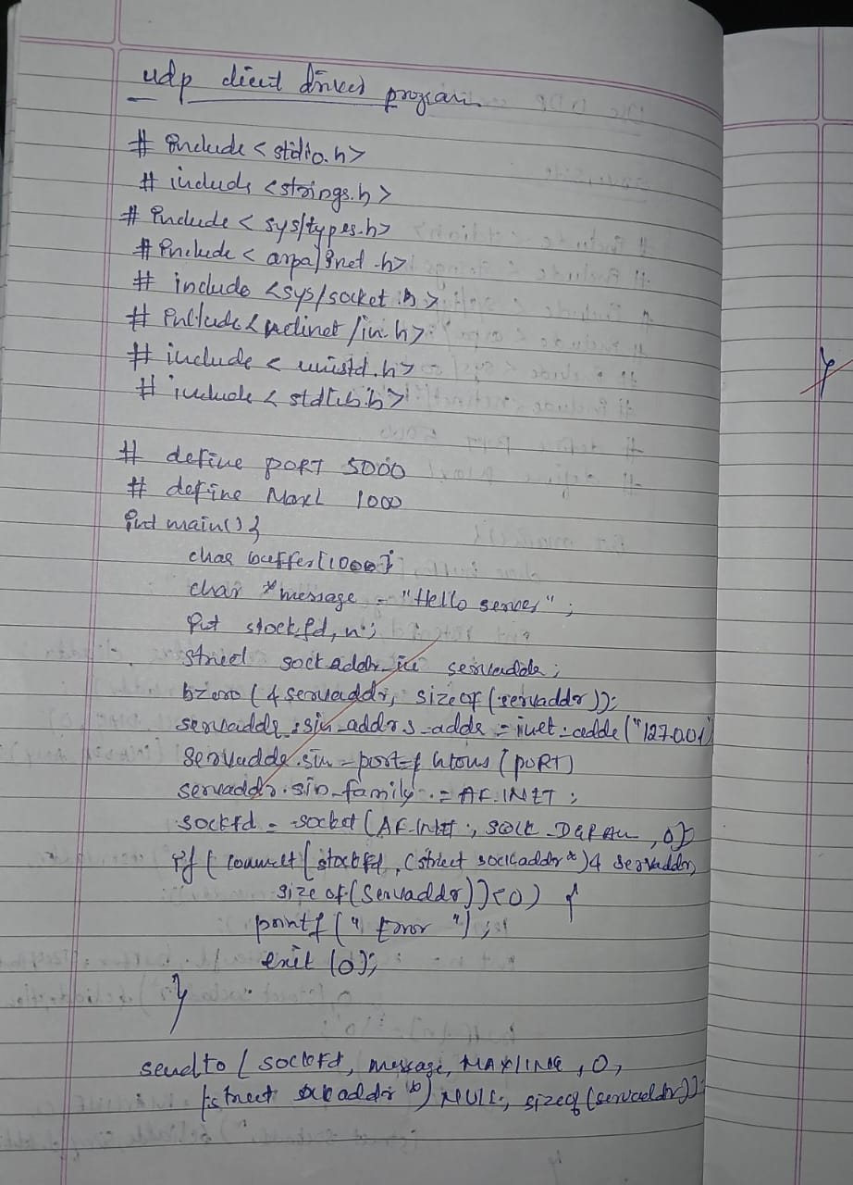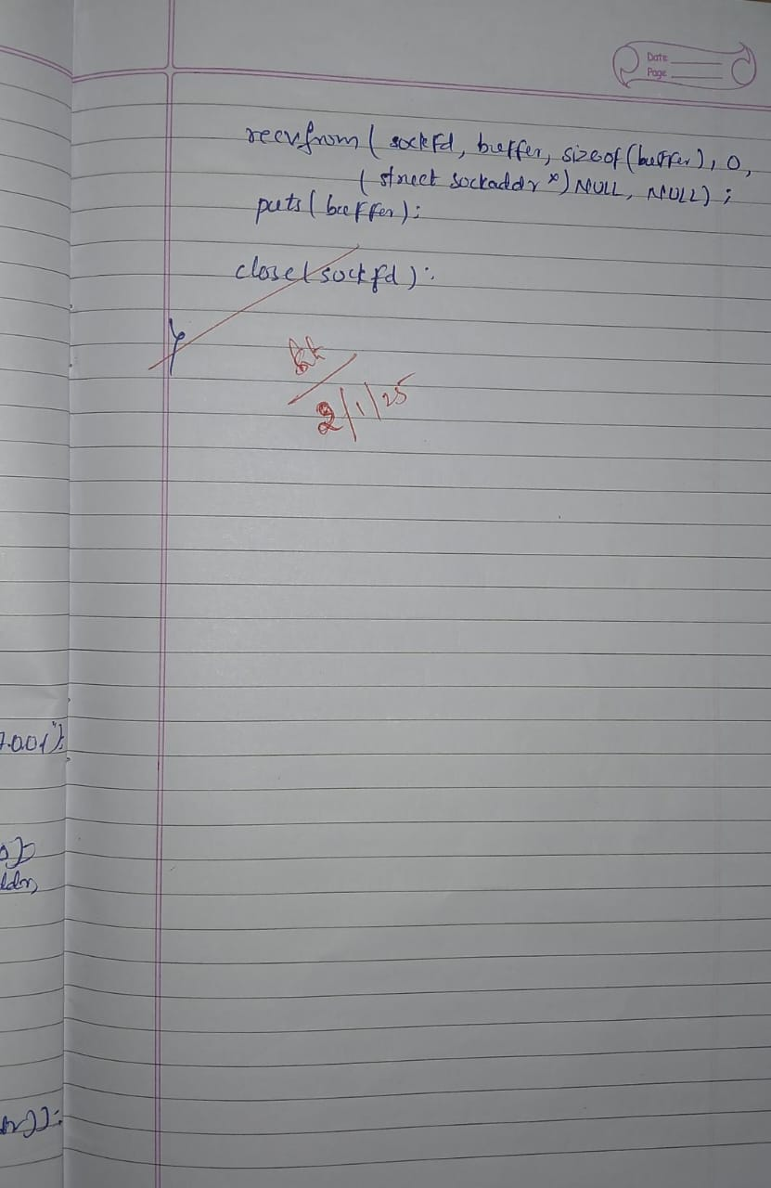

Server Output:  
Server is online

Hello Server

Client Output:  
Hello Client